**ABSTRACT**

The goal of the project is deploy the basic website architecture on Azure. We will have two sets of server, first set of server will be in US region and other set of servers would be in the Indian region. We will have a load balancer on top of them and through this load balancer, if you are in the US region and if you go to a particular domain basically it should be pointed to the US Server automatically and once you are pointed to the US server your load balancer divide the load between the server and similarly for India you will be accessing the same domain it will pointed to the Indian servers and in the Indian server,there will be also load balancer which route your request to specific Indian Server.

# Index

|  |  |  |
| --- | --- | --- |
| **Sr. No.** | **Table of contents** | **Pg.**  **No.** |
| 1 | Introduction | 6 |
| 2 | Requirements | 9 |
| 3 | Case study | 11 |
| 4 | Deployment Steps | 12 |
| 5 | Conclusion | 71 |
| 6 | References | 72 |

**Introduction**

Azure is a cloud computing platform with an ever-expanding set of services to help you build solutions to meet your business goals. Azure services range from simple web services for hosting your business presence in the cloud to running fully virtualized computers for you to run your custom software solutions. Azure provides a wealth of cloud-based services like remote storage, database hosting, and centralized account management. Azure also offers new capabilities like AI and Internet of Things (IoT).

**Cloud Computing**

It's the delivery of computing services over the internet, which is otherwise known as the cloud. These services include servers, storage, databases, networking, software, analytics, and intelligence. Cloud computing offers faster innovation, flexible resources, and economies of scale.

**Why is cloud computing typically cheaper to use?**

Cloud computing is the delivery of computing services over the internet by using a pay-as-you-go pricing model. You typically pay only for the cloud services you use, which helps you:

* Lower your operating costs.
* Run your infrastructure more efficiently.
* Scale as your business needs change.

To put it another way, cloud computing is a way to rent compute power and storage from someone else's datacenter. You can treat cloud resources like you would resources in your own datacenter. When you're done using them, you give them back. You're billed only for what you use.

Instead of maintaining CPUs and storage in your datacenter, you rent them for the time that you need them. The cloud provider takes care of maintaining the underlying infrastructure for you. The cloud enables you to quickly solve your toughest business challenges, and bring cutting-edge solutions to your users.

**Why should I move to the cloud?**

The cloud helps you move faster and innovate in ways that were once nearly impossible.

In our ever-changing digital world, two trends emerge:

* Teams deliver new features to their users at record speeds.
* Users expect an increasingly rich and immersive experience with their devices and with software.

Software releases were once scheduled in terms of months or even years. Today, teams release features in smaller batches that are often scheduled in days or weeks. Some teams even deliver software updates continuously--sometimes with multiple releases within the same day.

Think of all the ways you interact with devices that you couldn't do a few years ago. Many devices can recognize your face and respond to voice commands. Augmented reality changes the way you interact with the physical world. Household appliances are even beginning to act intelligently. These technologies are only a few examples, and many of them are powered by the cloud.

To power your services and deliver innovative and novel user experiences more quickly, the cloud provides on-demand access to:

* A nearly limitless pool of raw compute, storage, and networking components.
* Speech recognition and other cognitive services that help make your application stand out from the crowd.
* Analytics services that deliver telemetry data from your software and devices.

**What is the Azure portal?**

The Azure portal is a web-based, unified console that provides an alternative to command-line tools. With the Azure portal, you can manage your Azure subscription by using a graphical user interface. You can:

* Build, manage, and monitor everything from simple web apps to complex cloud deployments.
* Create custom dashboards for an organized view of resources.
* Configure accessibility options for an optimal experience.

The Azure portal is designed for resiliency and continuous availability. It maintains a presence in every Azure datacenter. This configuration makes the Azure portal resilient to individual datacenter failures and avoids network slowdowns by being close to users. The Azure portal updates continuously and requires no downtime for maintenance activities.

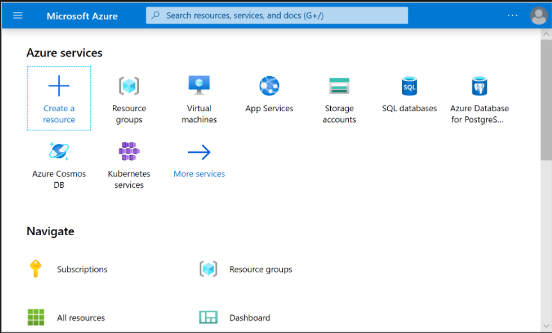

**Requirements**

To have a proper knowledge about the hardware components as well as the software

components of the project is a must.

From user side they must have three things

1. **Desktop/Laptop.**
2. **Good Internet Connection.**
3. **Azure Accounts.**

**Get started with Azure accounts**

To create and use Azure services, you need an Azure subscription. When you're completing Learn modules, most of the time a temporary subscription is created for you, which runs in an environment called the Learn sandbox. When you're working with your own applications and business needs, you need to create an Azure account, and a subscription will be created for you. After you've created an Azure account, you're free to create additional subscriptions. For example, your company might use a single Azure account for your business and separate subscriptions for development, marketing, and sales departments. After you've created an Azure subscription, you can start creating Azure resources within each subscription.

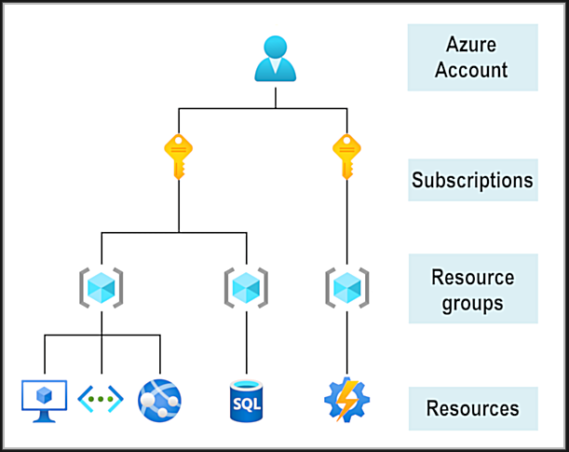

If you're new to Azure, you can sign up for a free account on the Azure website to start exploring at no cost to you. When you're ready, you can choose to upgrade your free account. You can create a new subscription that enables you to start paying for Azure services you need to use that are beyond the limits of a free account.

**Create an Azure account**

You can purchase Azure access directly from Microsoft by signing up on the Azure website or through a Microsoft representative. You can also purchase Azure access through a Microsoft partner. Cloud Solution Provider partners offer a range of complete managed-cloud solutions for Azure.

For more information on how to create an Azure account, see the Create an Azure account learning module.

**What is the Azure free account?**

The Azure free account includes:

* Free access to popular Azure products for 12 months.
* A credit to spend for the first 30 days.
* Access to more than 25 products that are always free.

The Azure free account is an excellent way for new users to get started and explore. To sign up, you need a phone number, a credit card, and a Microsoft or GitHub account. The credit card information is used for identity verification only. You won't be charged for any services until you upgrade to a paid subscription.

**What is the Azure free student account?**

The Azure free student account offer includes:

* Free access to certain Azure services for 12 months.
* A credit to use in the first 12 months.
* Free access to certain software developer tools.

The Azure free student account is an offer for students that gives $100 credit and free developer tools. Also, you can sign up without a credit card.

**Case Study**

The XYZ company wants to deploy the basic website architecture on Azure. They want to have two sets of server, first set of server will be in US region and other set of servers would be in the Indian region. We will have a load balancer on top of them and through this load balancer, if you are in the US region and if you go to a particular domain basically it should be pointed to the US Server automatically and once you are pointed to the US server your load balancer divide the load between the server and similarly for India you will be accessing the same domain it will pointed to the Indian servers and in the Indian server,there will be also load balancer which route your request to specific Indian Server.

**Deployment Steps**

Go to Azure portal

Type **URL** : **portal.azure.com** on browser



After sign up or sign in below page will open

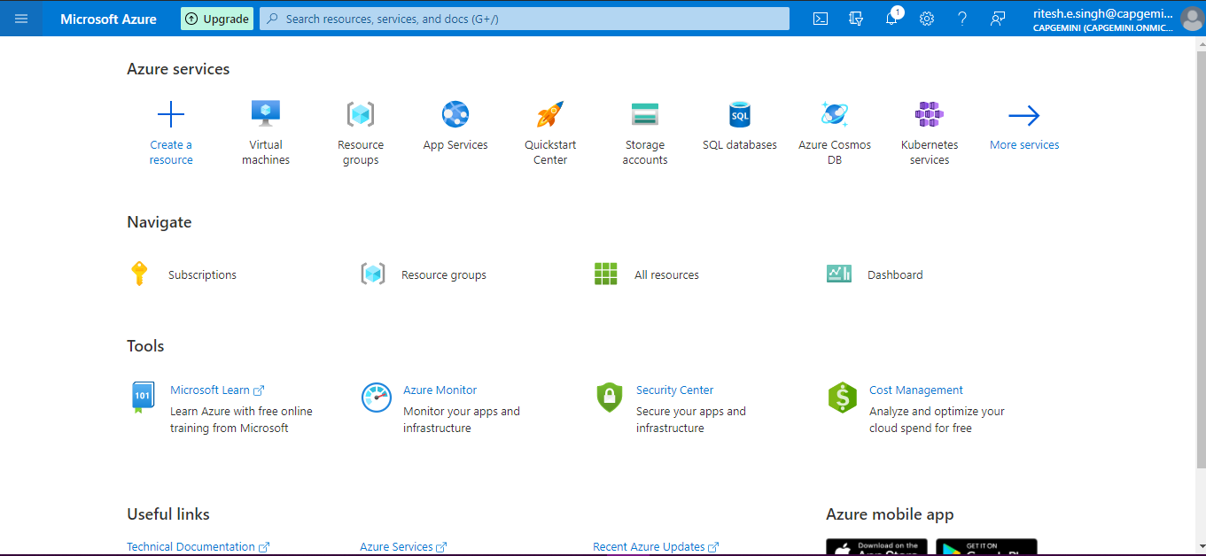

click **+Create a resource** icon

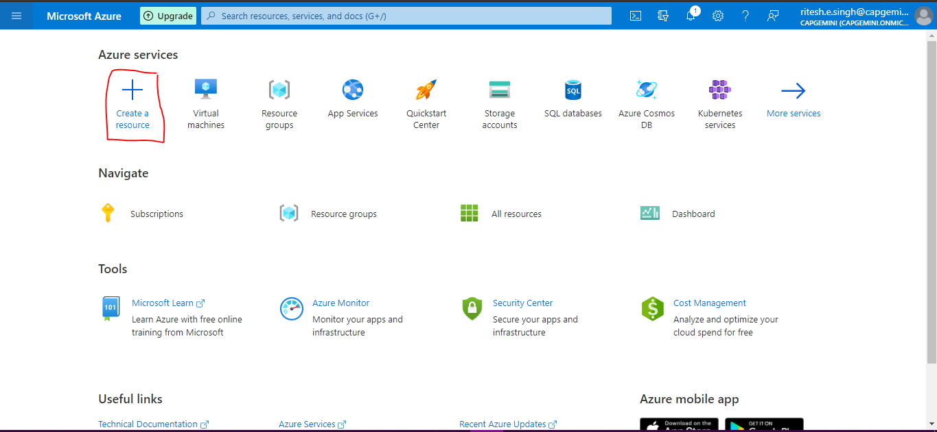

Type virtual machines in search bar and click on virtual machines(Highlighted)

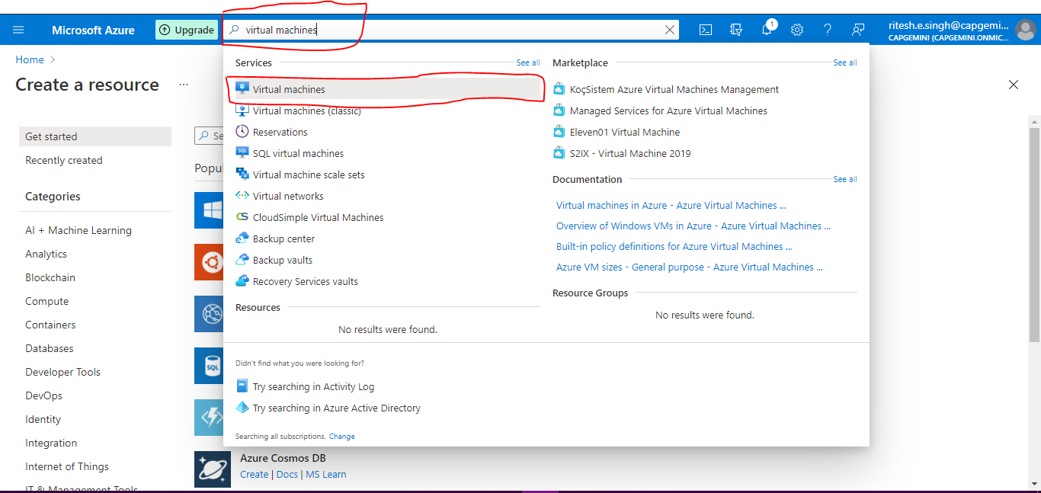

click on **+Create** and select and click on **+Virtual Machine**

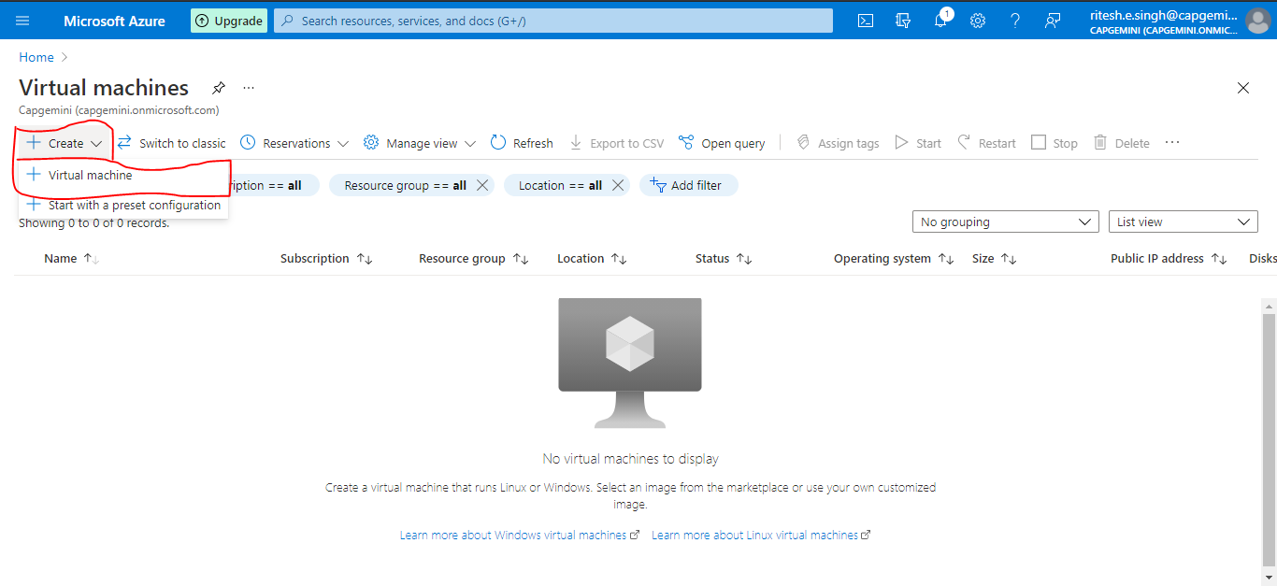

Below Create a virtual machine page will open

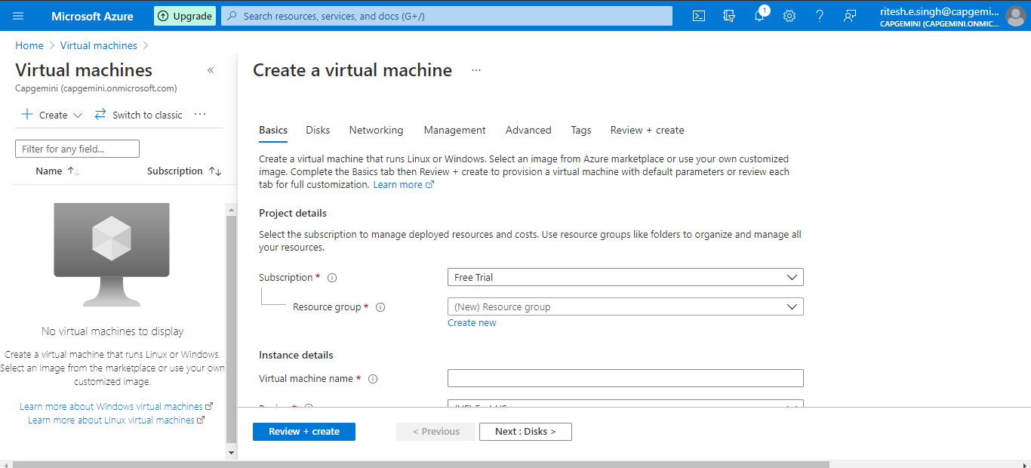

Click on **Create New** for Resource Group and provide the **Name** i.e rg-dsaiproject (any name according to you) and click **OK**

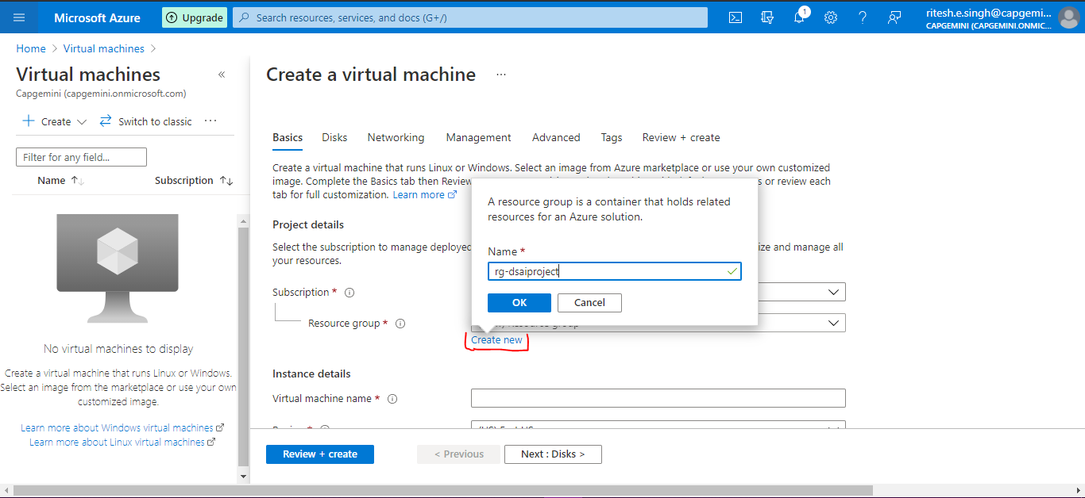

Provide below highlighted details in below **two images** and click **Next:Disks>**

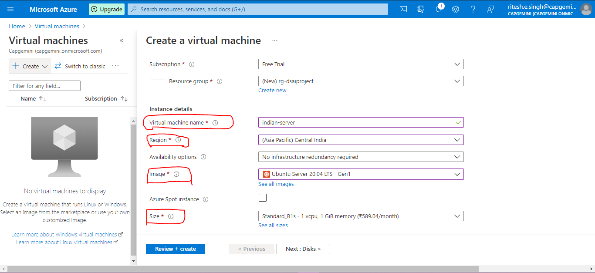

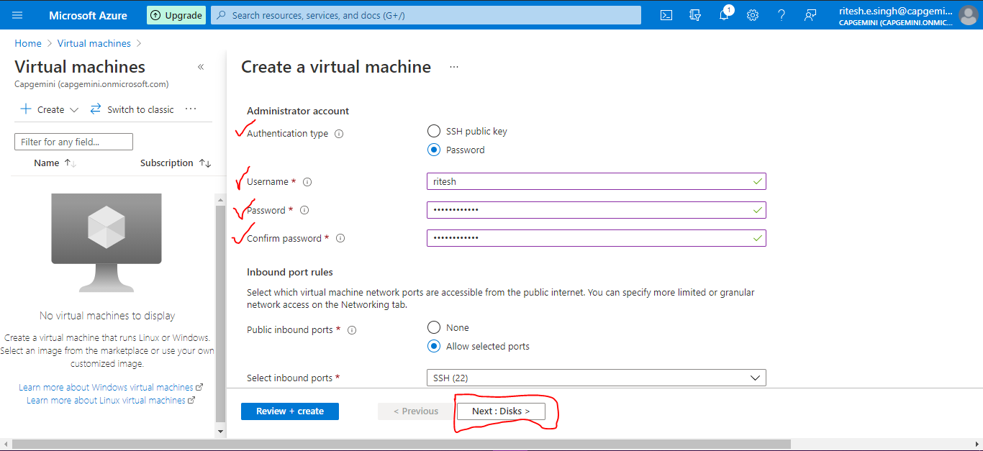

Select **OS disk type - Standard SSD** and click **Next:Networking>**

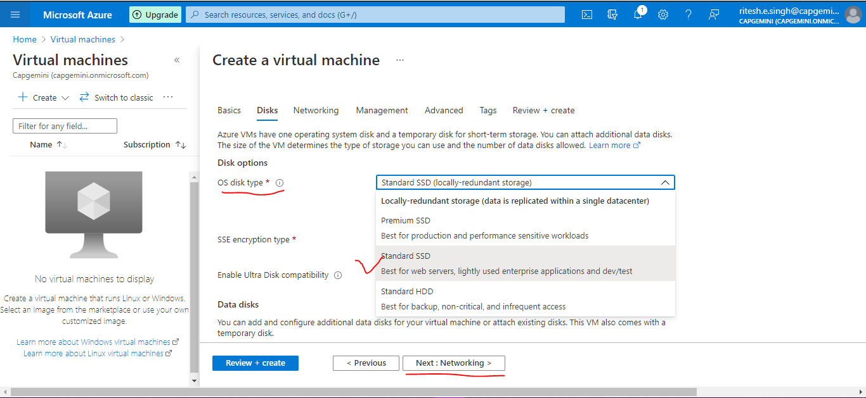

Keep details Default and click on **Next:Management>**

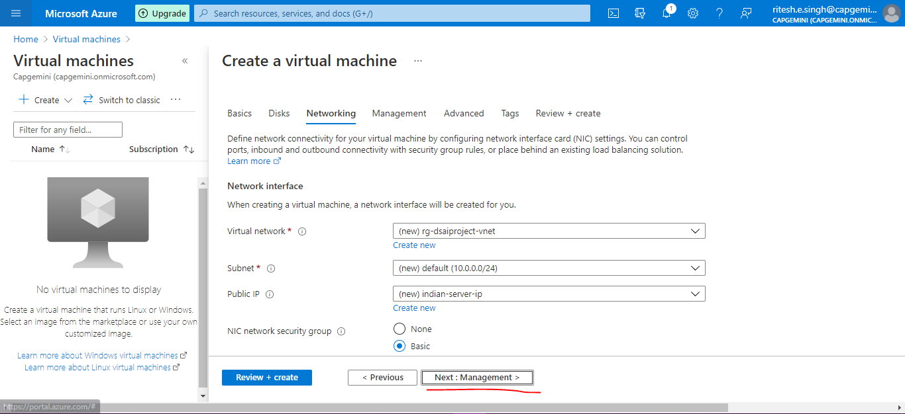

Keep Default and click on **Next:Advanced>**

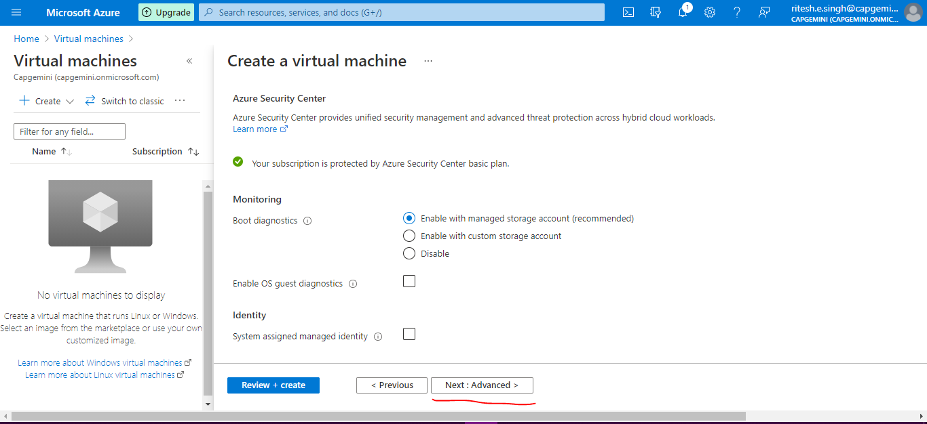

Keep Default and click on **Next:Tags>**

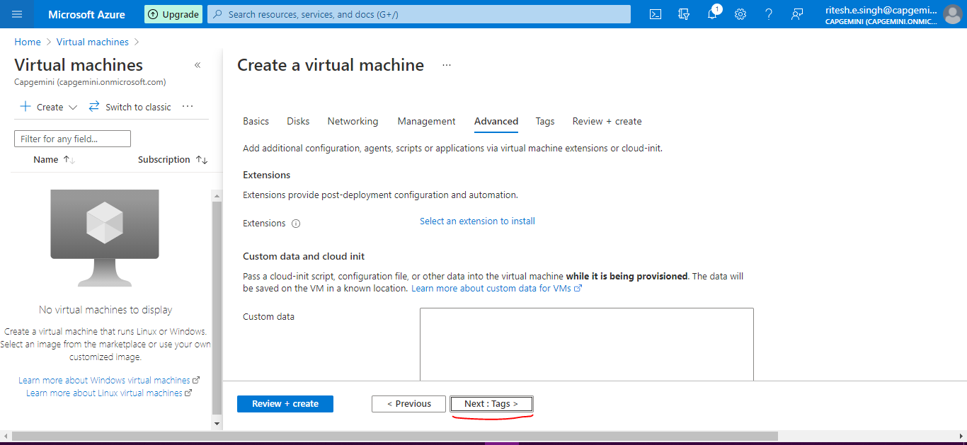

Keep Default and click on **Next:Review + create >**

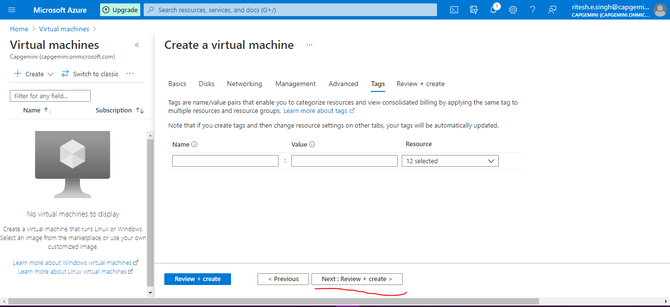

On this page it will give the product details and will give summarized information of configuration you have performed above.

You can see Validation passed

Click **Create**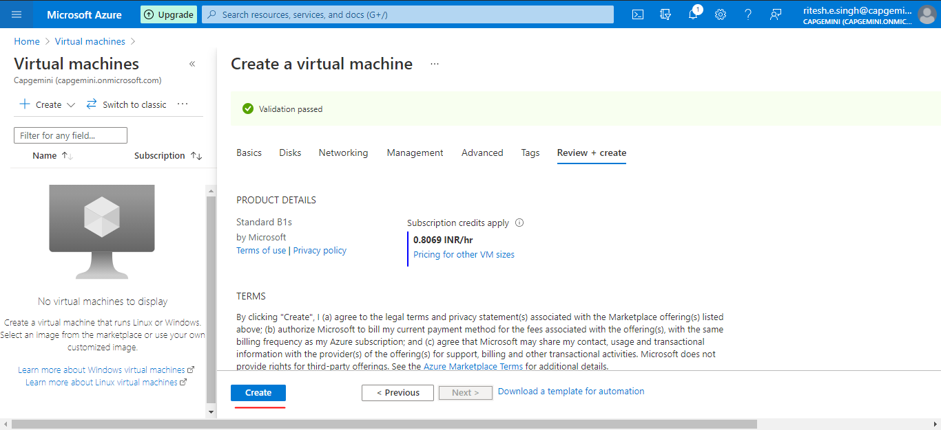

Once clicked on Create you will see Deployment is in Progress

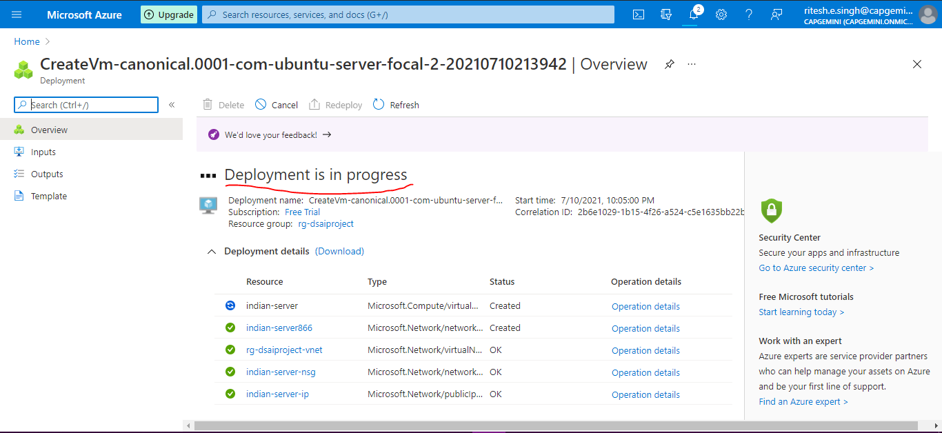

Once complete will show Your deployment is complete

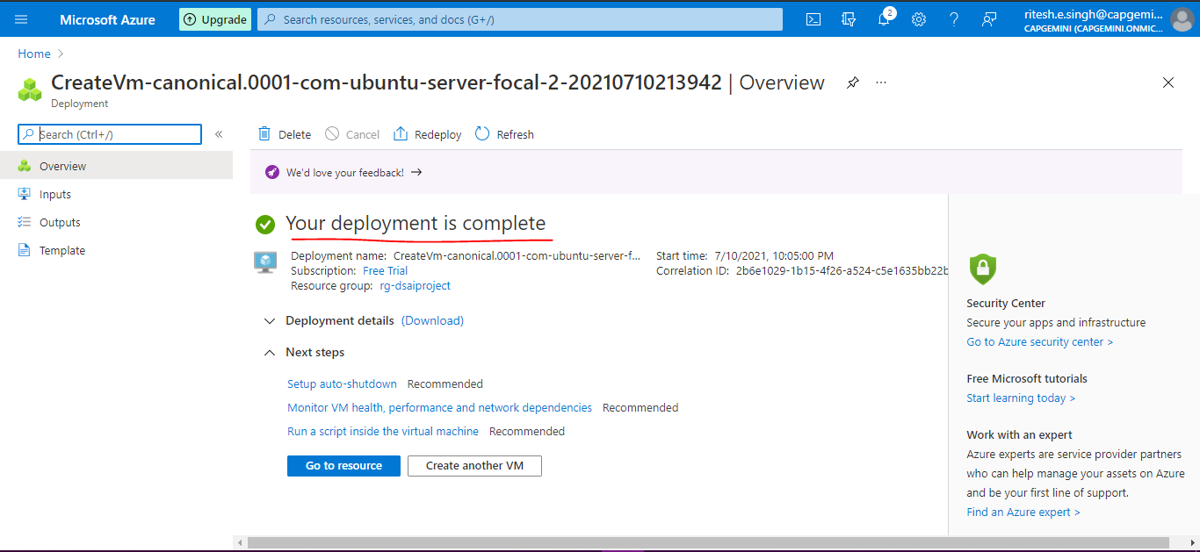

Once deployed go to Home page and click on **Resource groups**

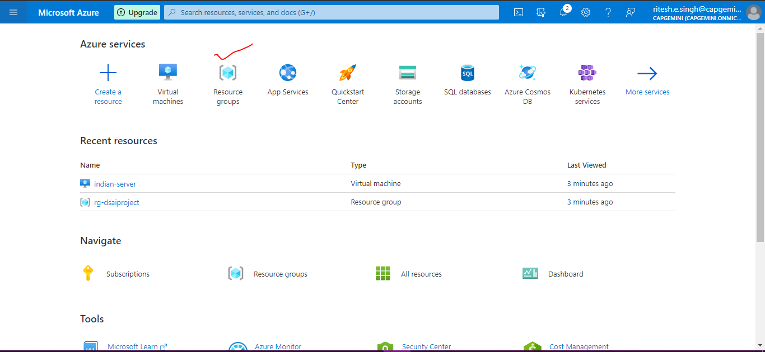

You can see your resource group which you created **rg-dsaiproject** .just click on it

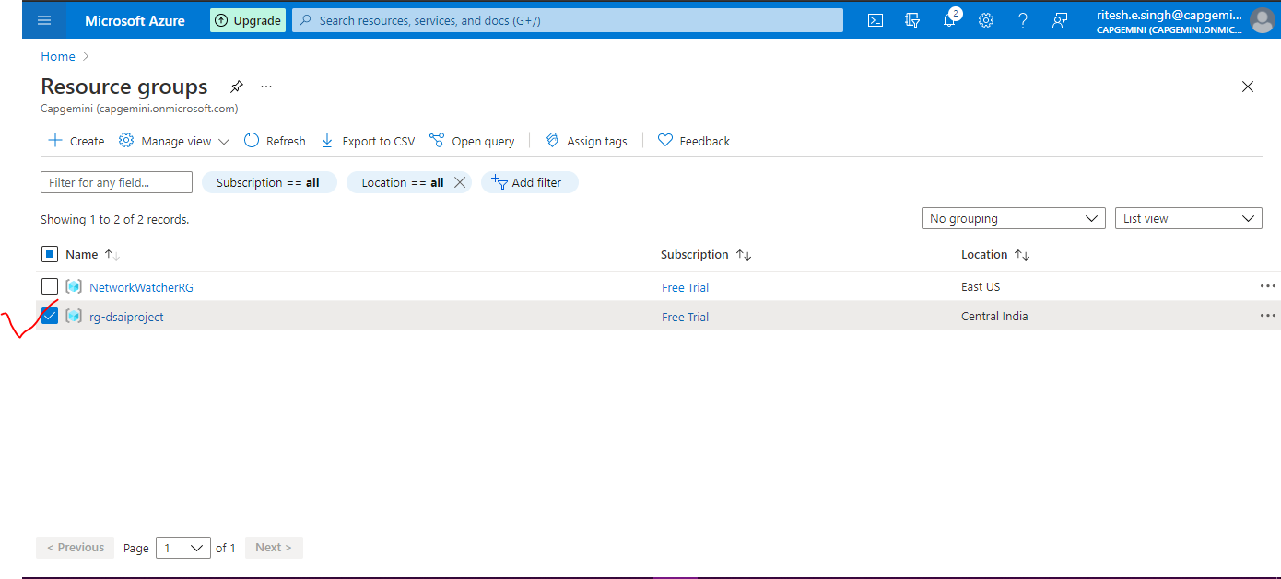

Under this resource group you can see your deployed Indian-server which you configured.

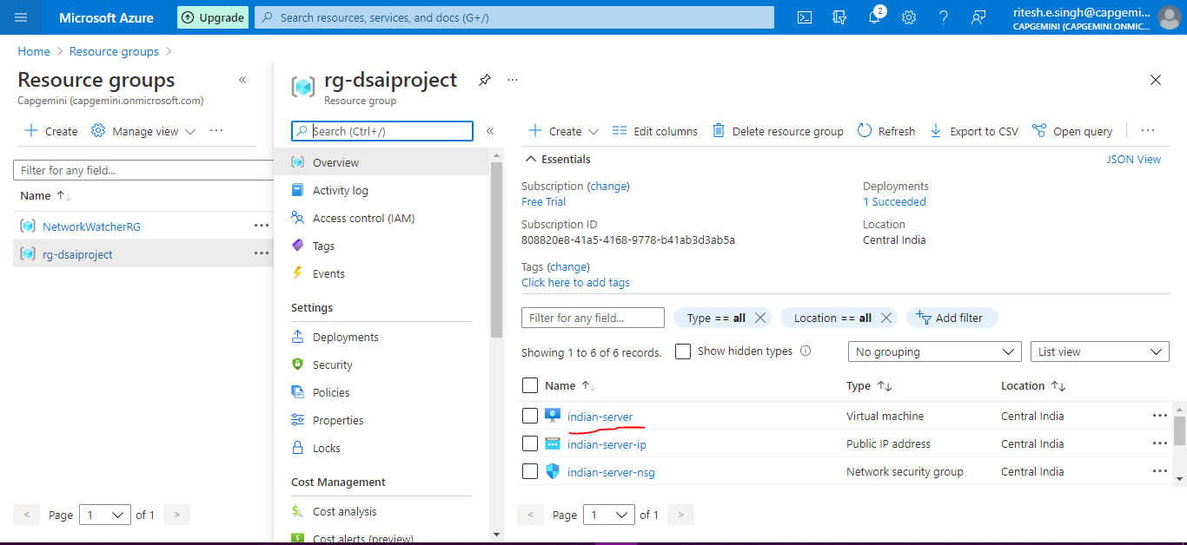

Now we will deploy for US Server

Click on **+Create**

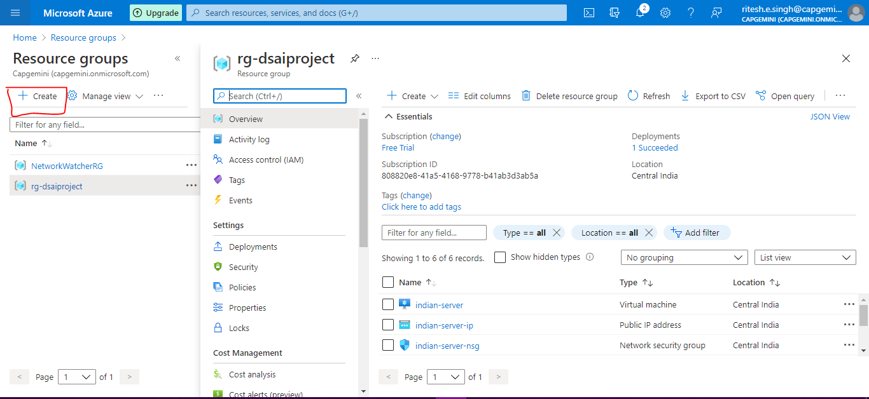

Provide below details and click on **Review + create**

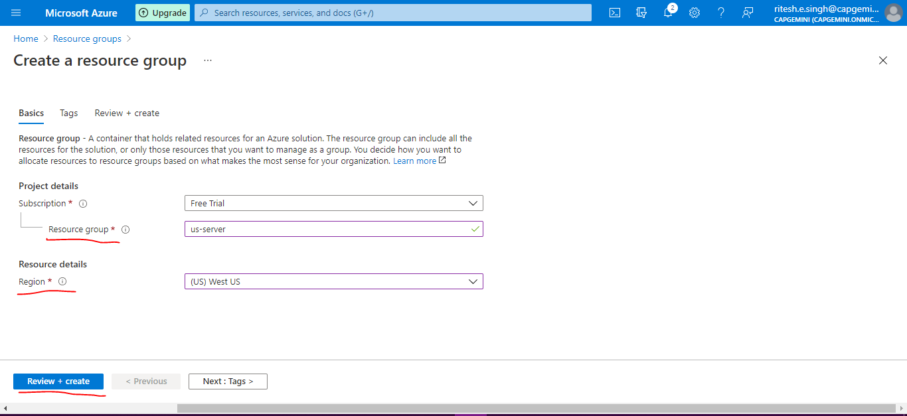

Validation is passed now Click on **Create**

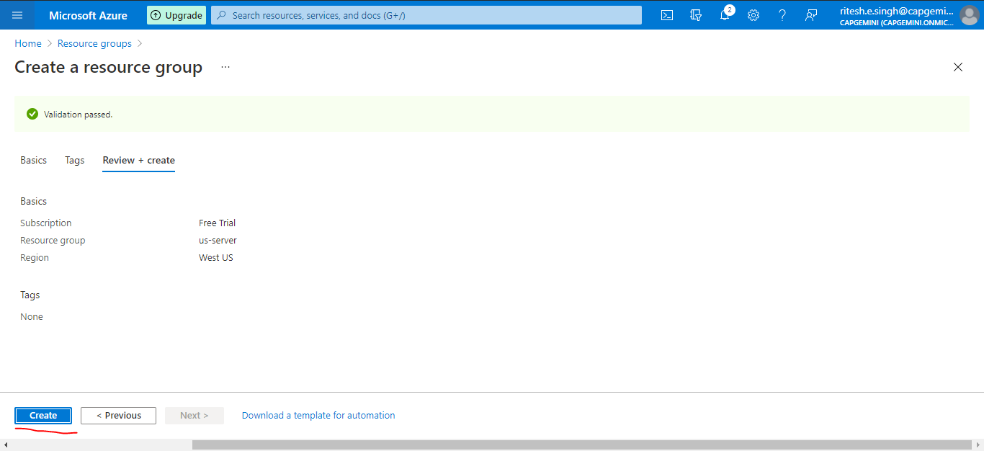

Now u can see us-server resource group also along with rg-dsaiproject for Indian server

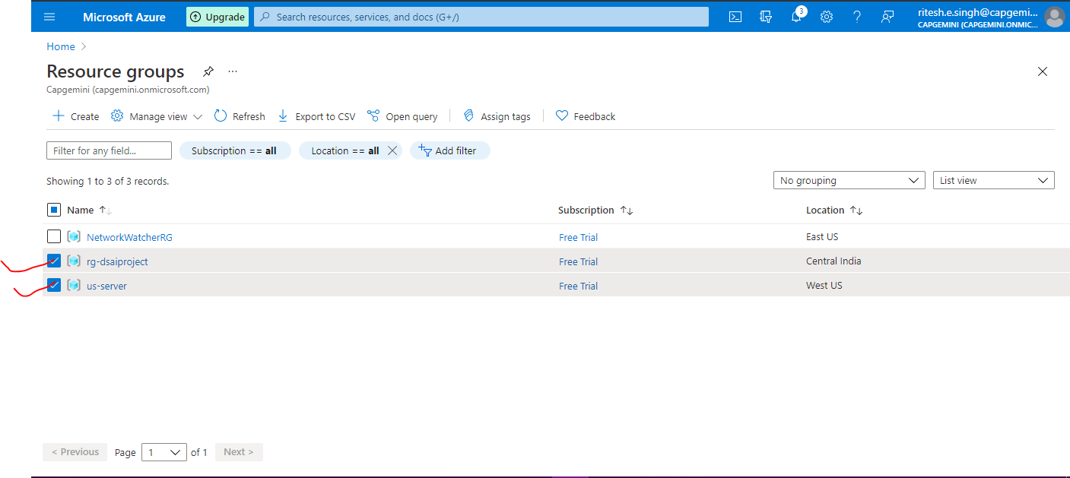

Create Virtual Machine for US- Server 1 (same steps as above created)

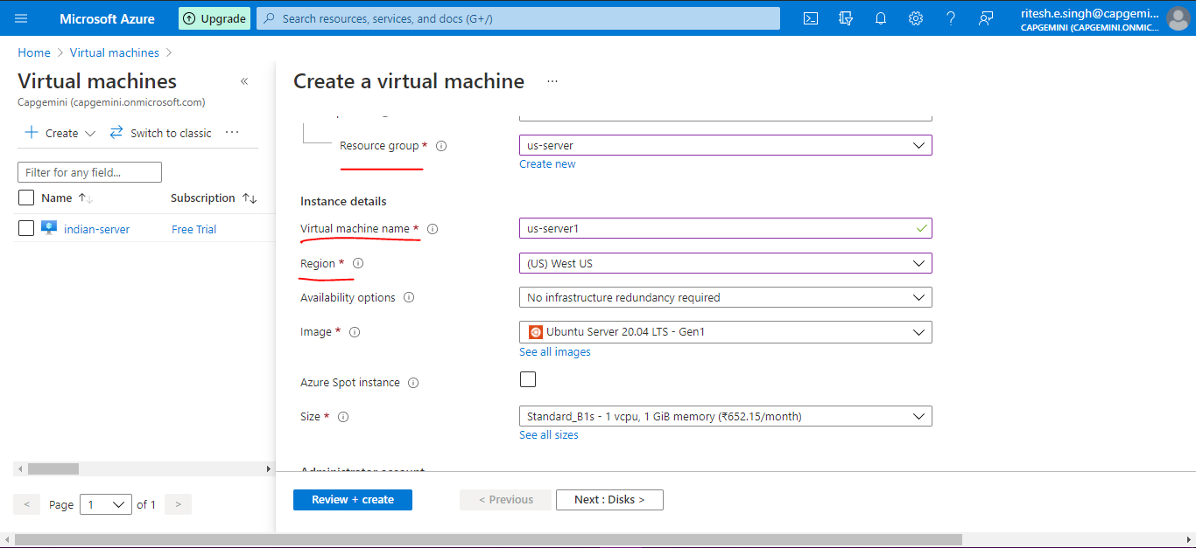

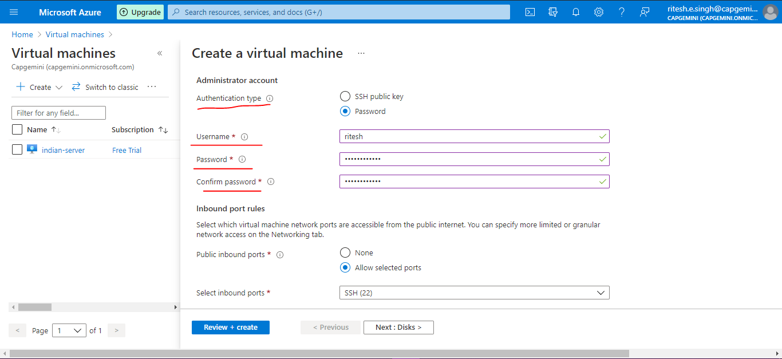

Similarly create Indian server 2 and US server 2 virtual machine and check after deployment is complete in their respective resource group

----------------------------------------------------------------------------------------------------------------

For Windows Download putty once you run and install

After opening putty below it looks like

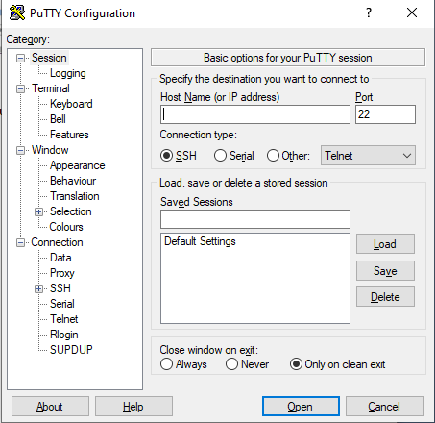

Go to india-server virtual machine in resource group i.e rg-dsaiproject

i.e click on indian-server

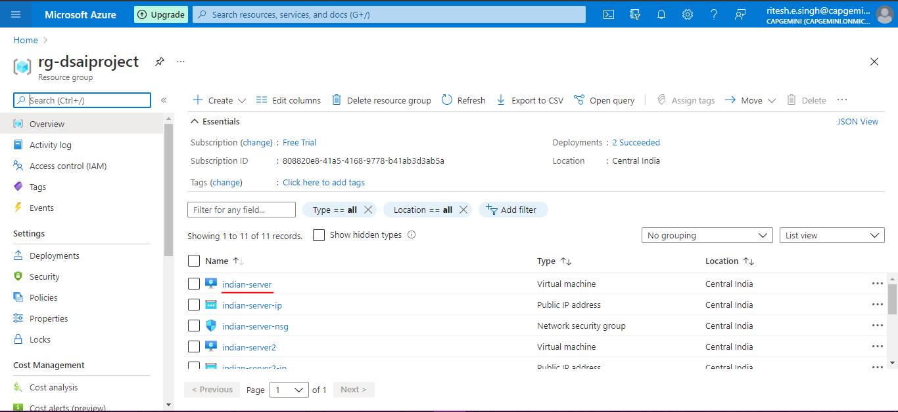

Copy **Public IP address**

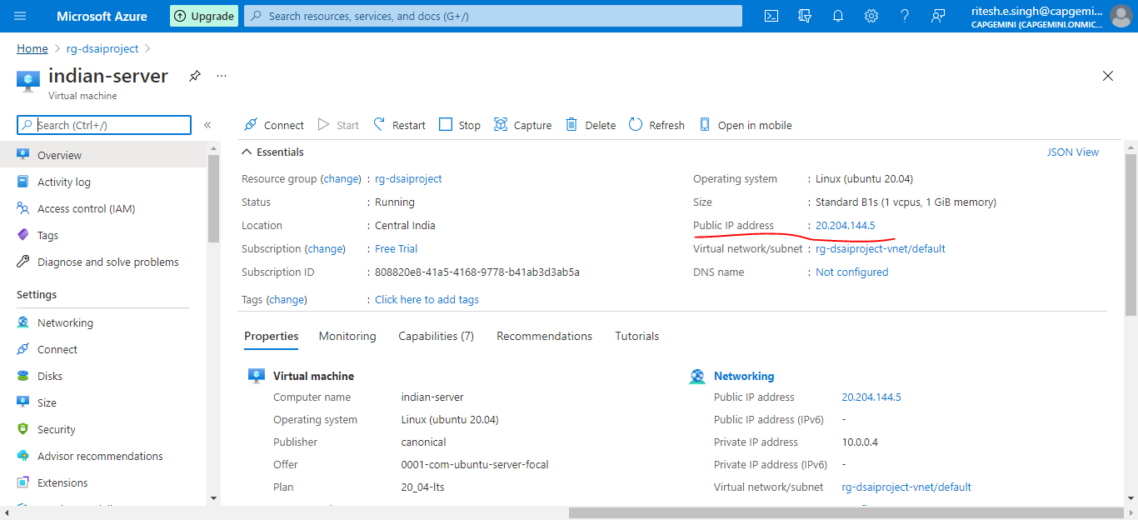

Go and paste IP address in putty as shown below and click **Open**

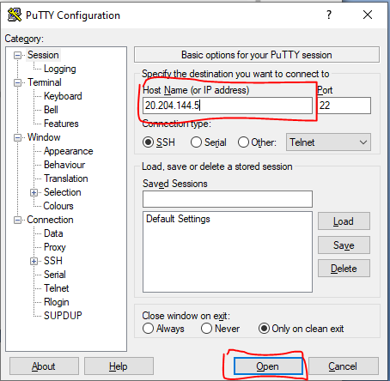

Below Terminal will open

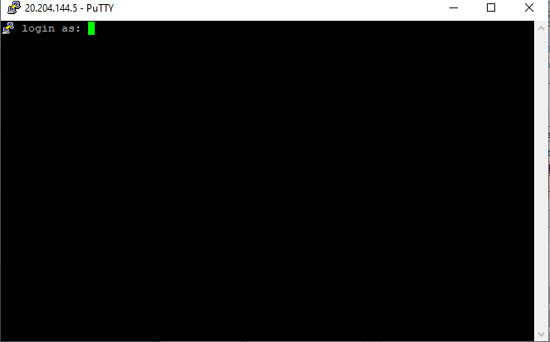

Provide the login details and you are logged in now on indian-server

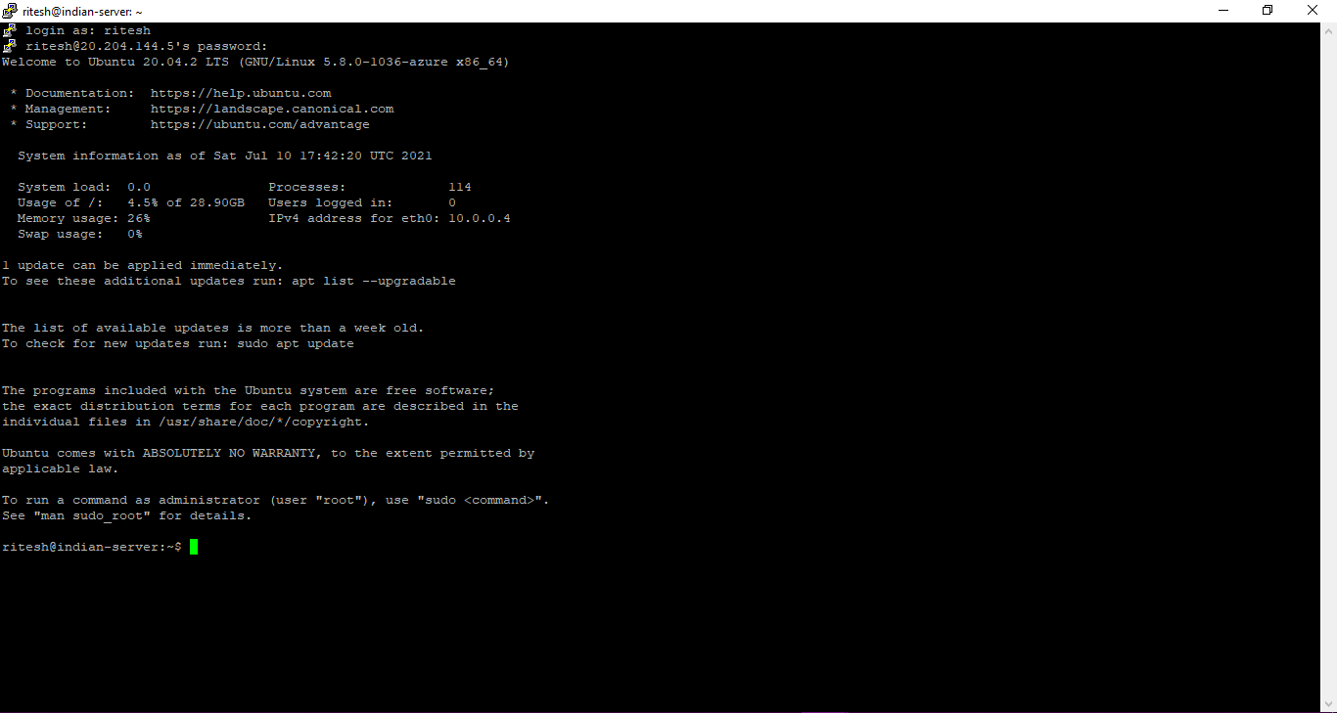

Similarly do for indian-server2

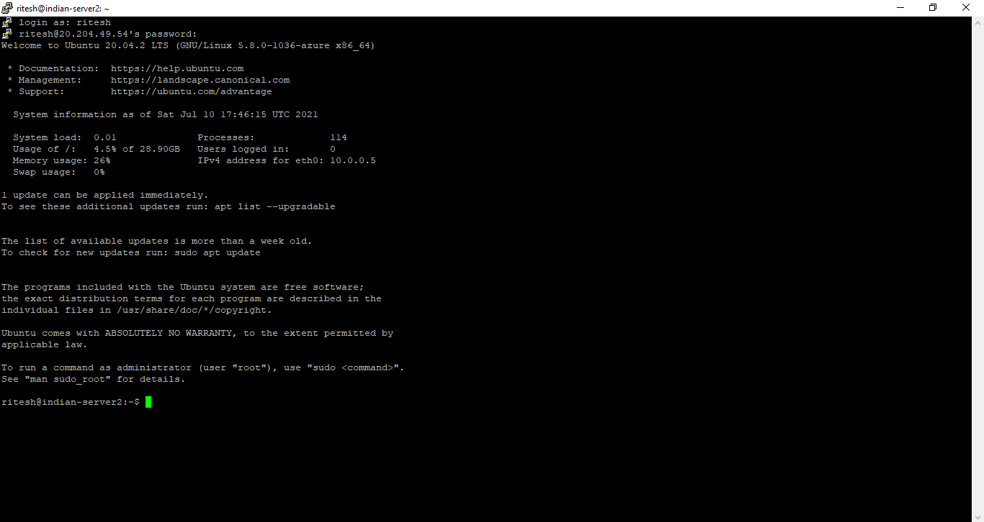

**Similarly you can do for us-server1 and us-server2(as above steps)**

On **indian-server**

Type cmd - **sudo apt-get update**

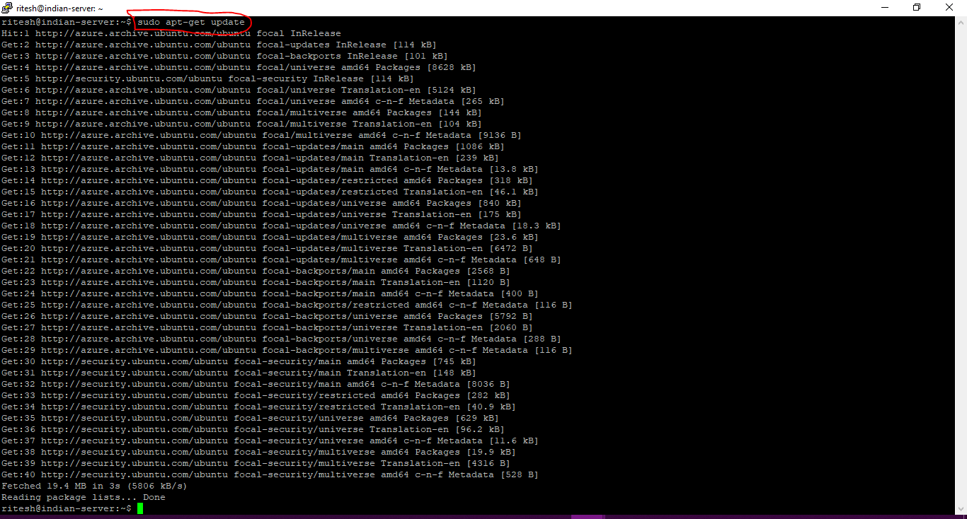

Type cmd **sudo apt-get install apache2**

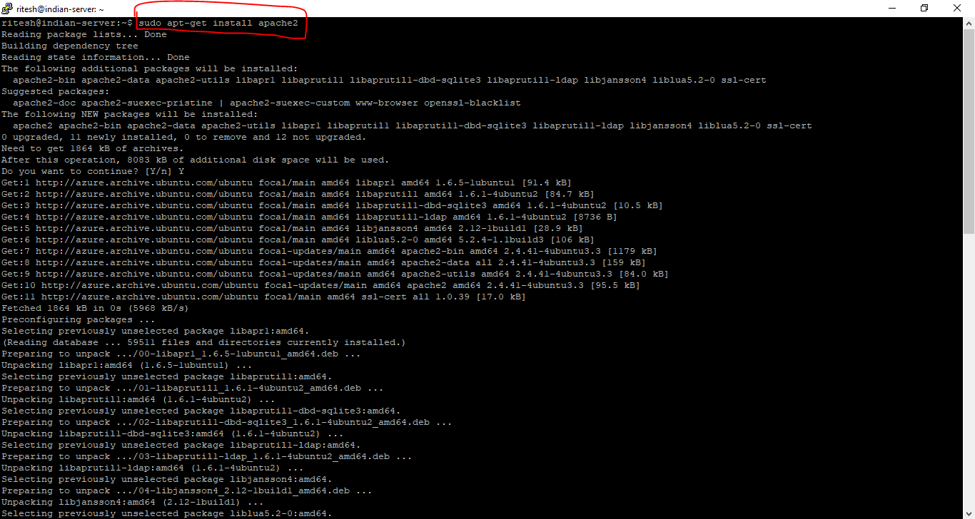

**Similarly type cmd for indian-server2 as shown below**

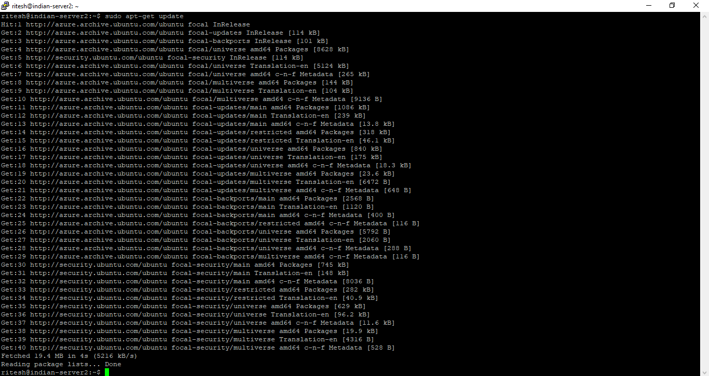

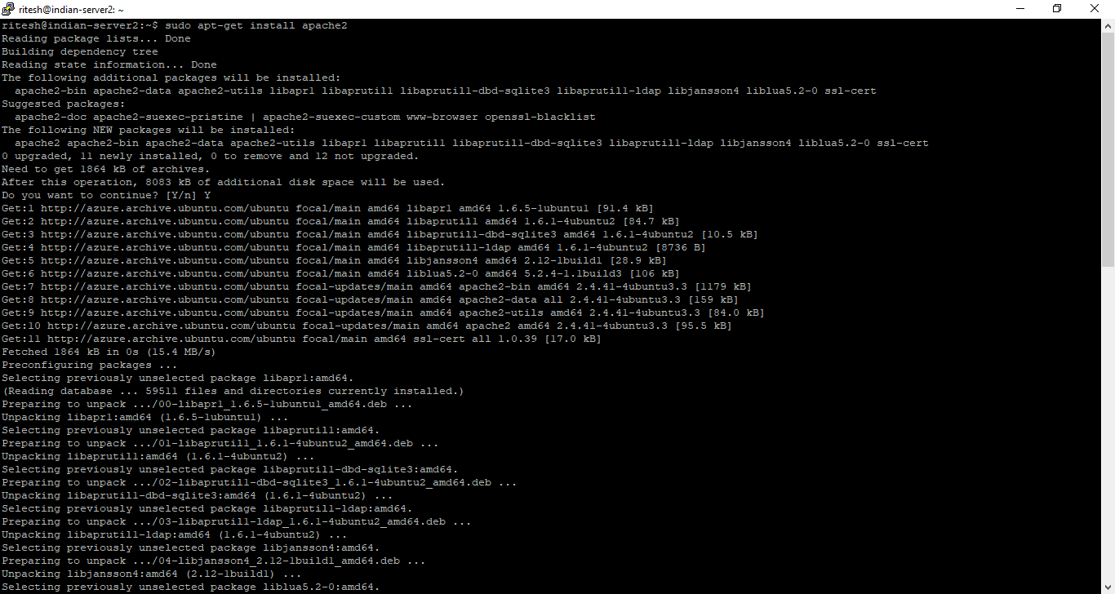

**Similarly perform above step for us-server1 and us-server2**

**After this copy public IP address of indian server or indian server2 and paste on browser and run you will see it will not open**

**For that**

This is indian-server so go to **Networking** under settings as shown below

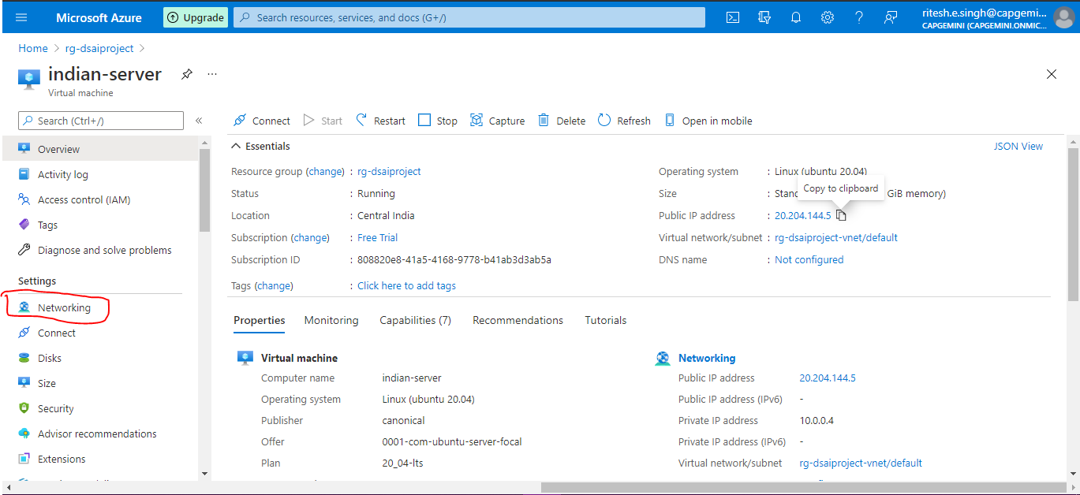

In Networking , click on **Add inbound port rule**

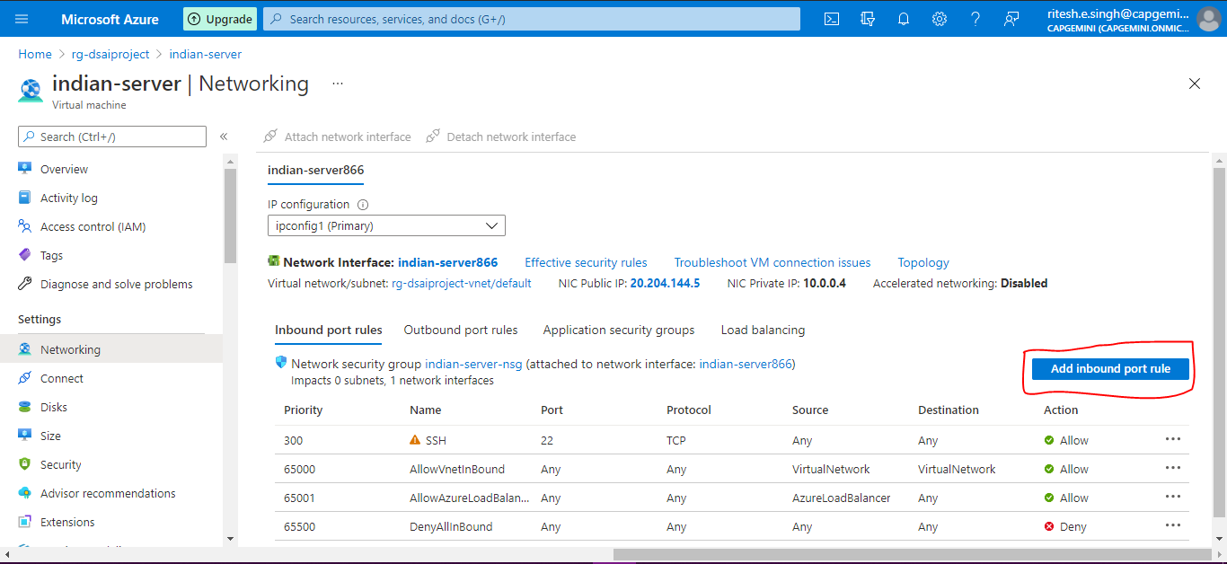

Change Destination port ranges from 8080 to 80

Protocol : Any

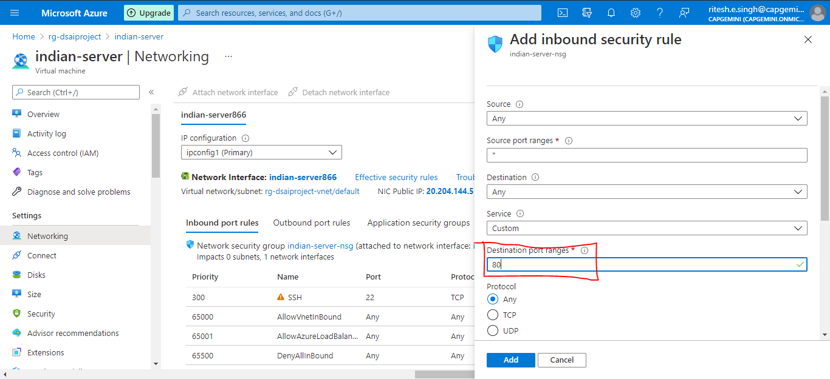

Action : Allow

Then click on **Add**

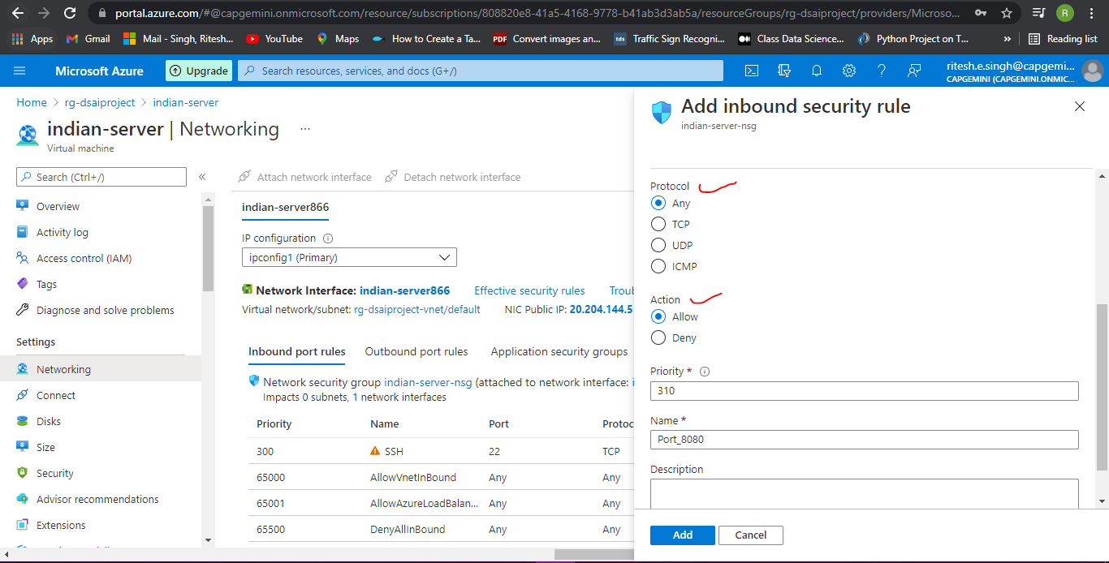

So 80 port configuration can be shown below

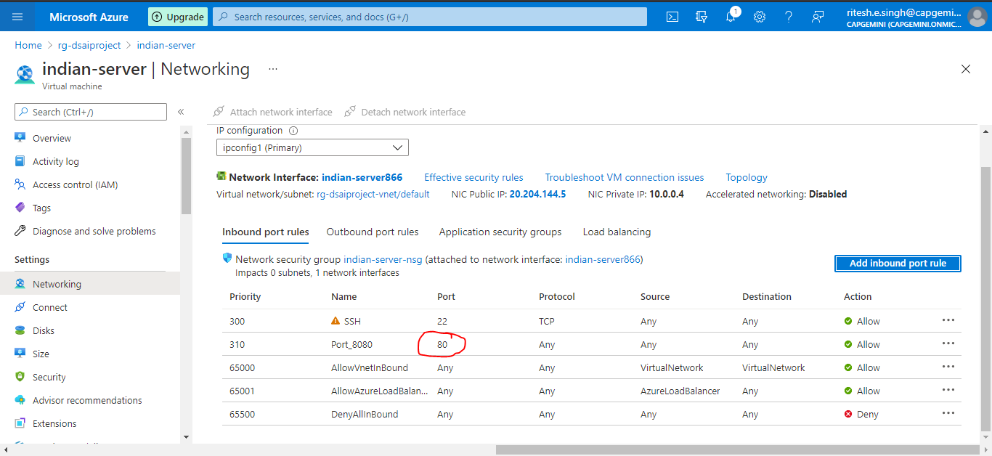

**Similarly do Networking setting for Indian-server2**

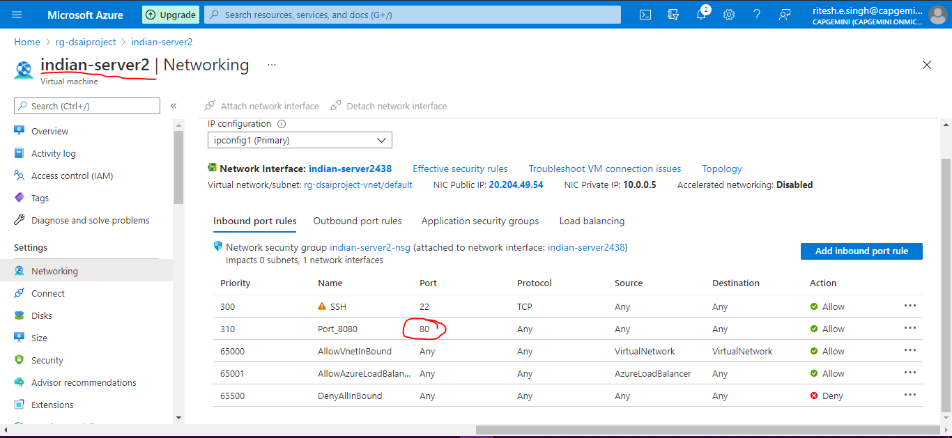

**Now you can see IP address for Indian-server and Indian-server2 get opens**

**Now we will replace this file (located at /var/www/html/index.html) (as shown below in image)**

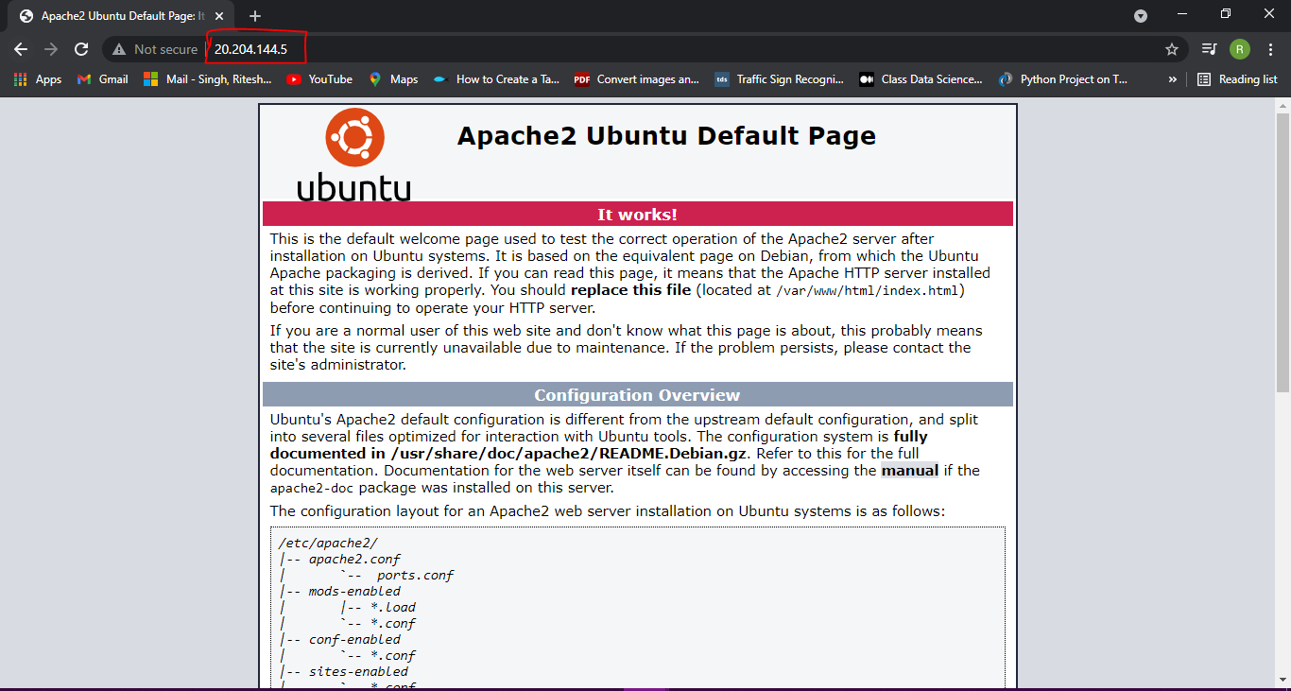

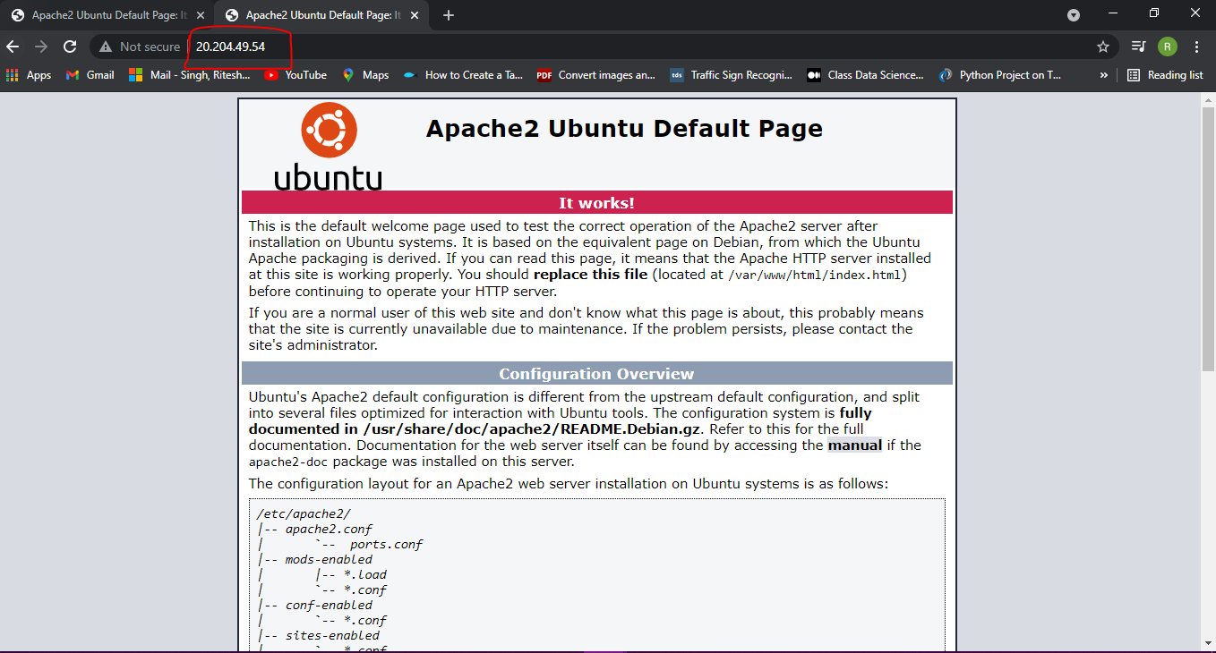

**Go to terminal Type cmd cd /var/www/html and press enter**



**Delete existing index.html file**

**Type cmd sudo rm index.html**

**Add index.html file**

**Type cmd sudo nano index.html**

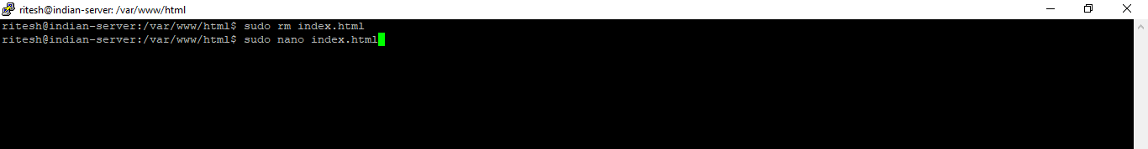

**Once you press enter after sudo nano cmd below editor will open**

**Type the basic html code in editor**

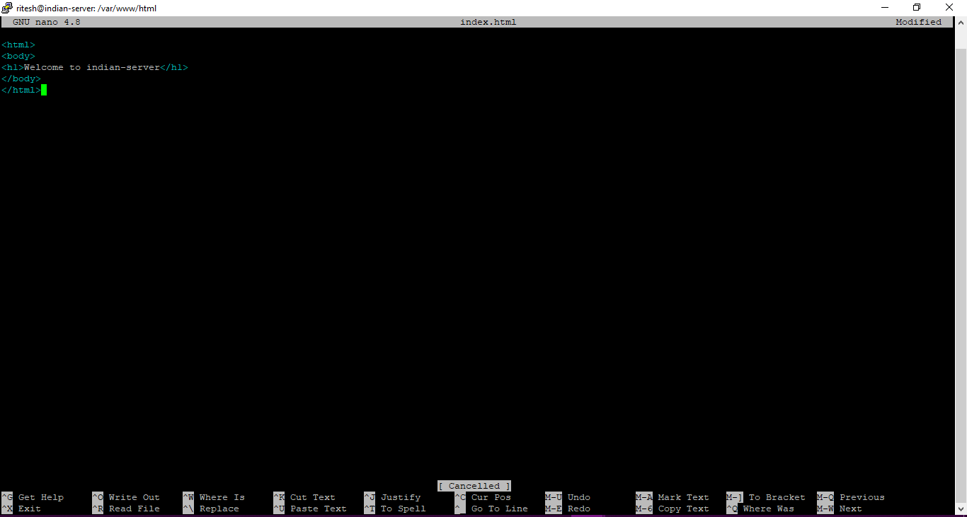

**You can show check the ip**

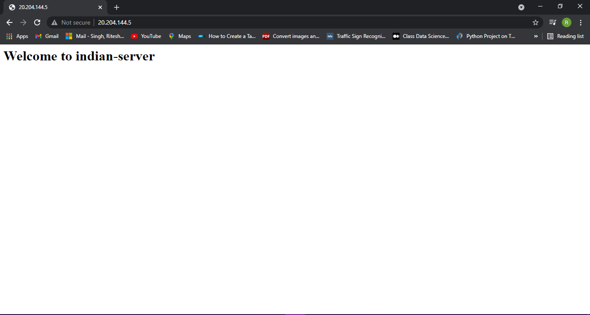

**Similarly do for Indian-server2**

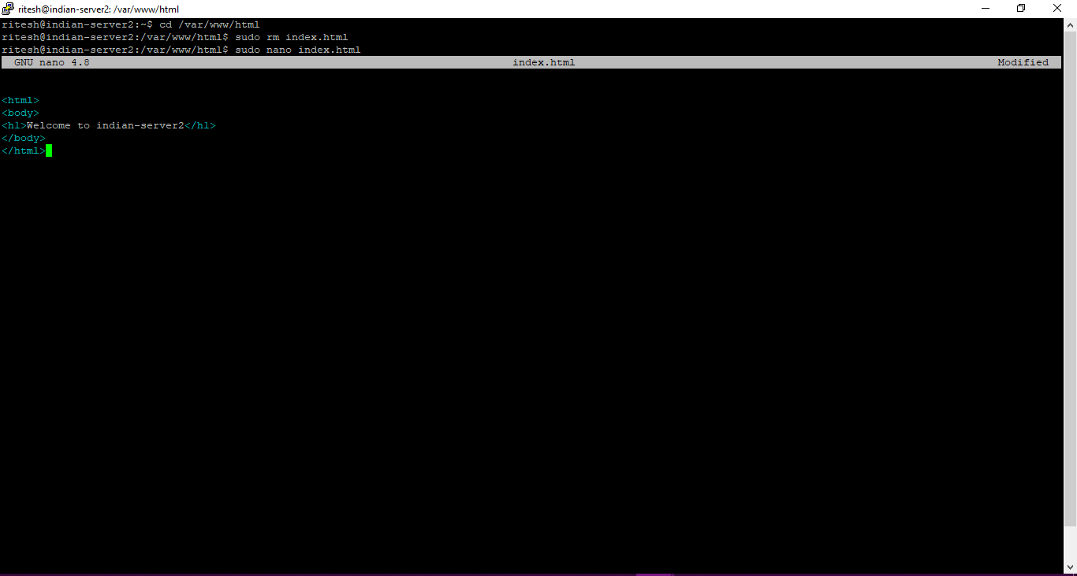

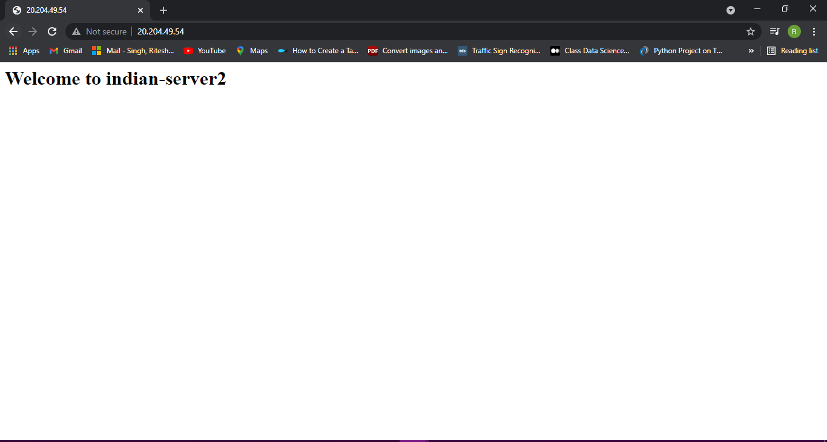

**Similarly perform above step for us-server1 and us-server2**

**Deploying Load Balancer**

Search for **Application gateways**

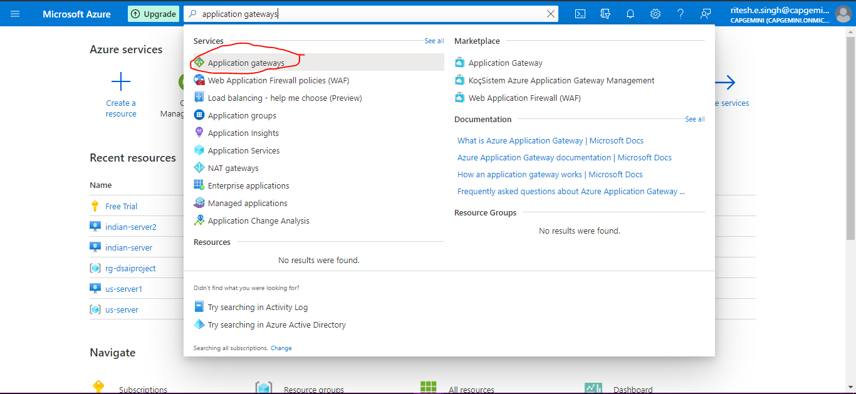

**Click on +Create**

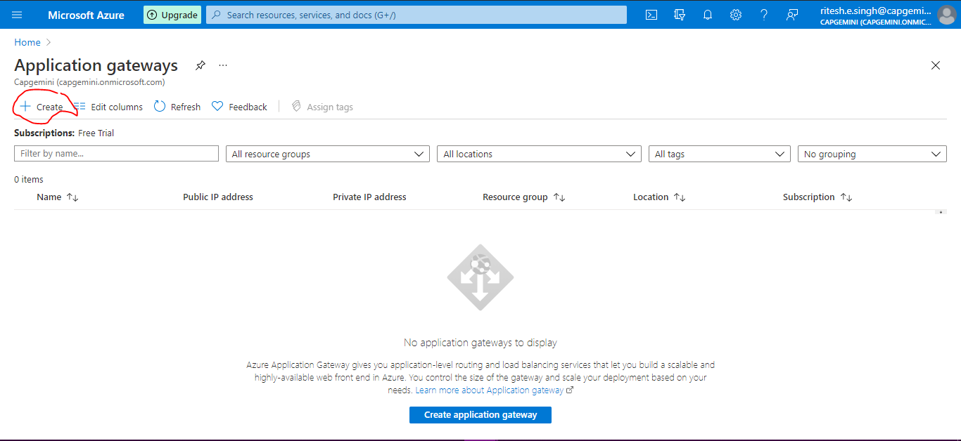

**Provide below details**

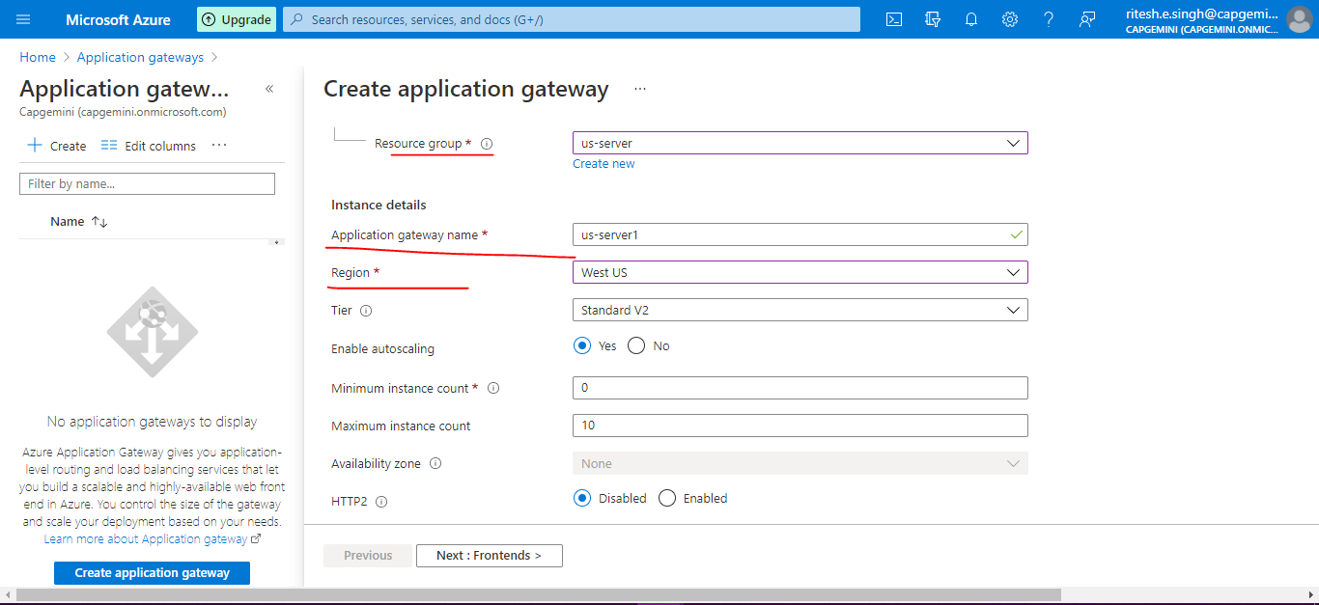

**Once you select Virtual network you will see error for subnet**

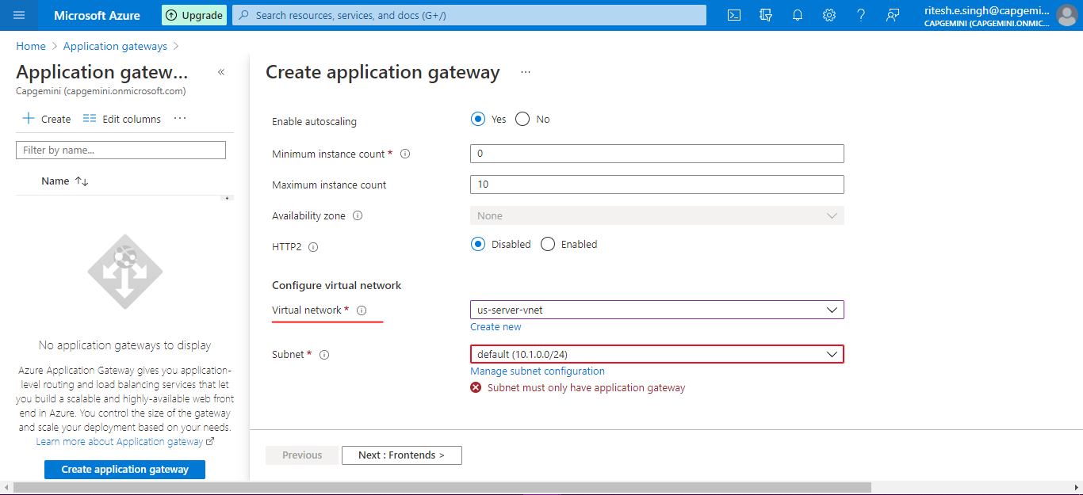

**For subnet error – open with new window for portal home page and search for virtual network**

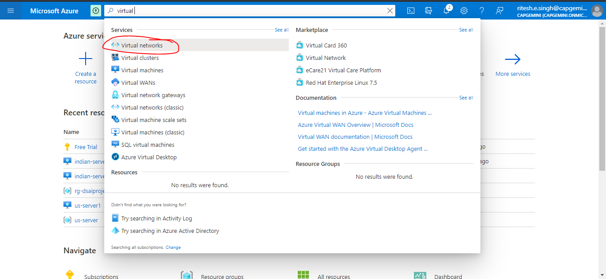

**Click on us-server-vnet**

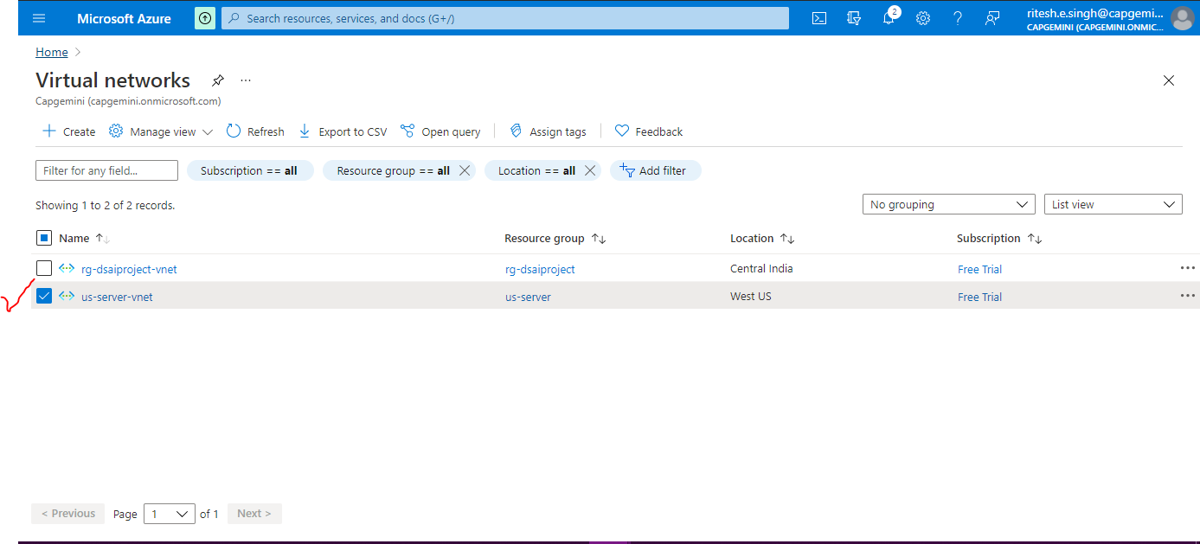

**Click on Subnet**

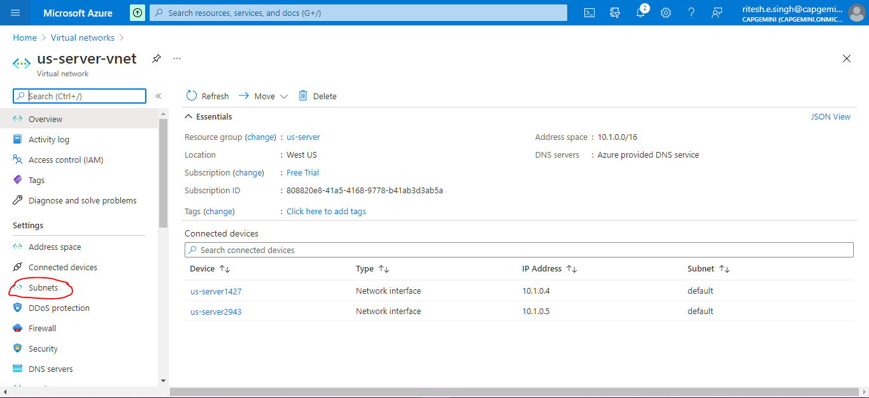

**Click +subnet**

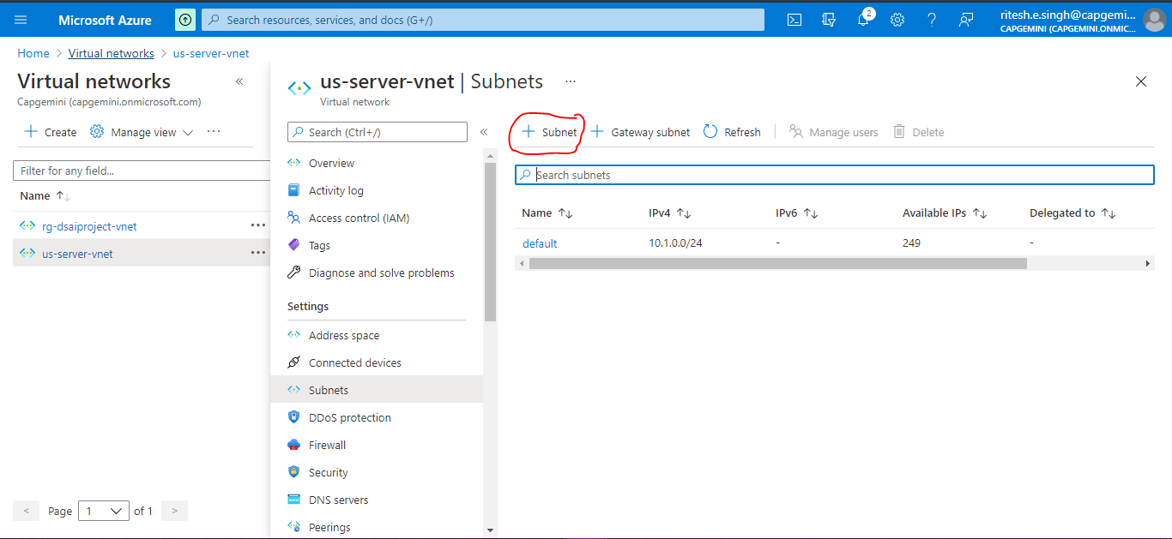

Provide name and subnet address range and Click on **Save**

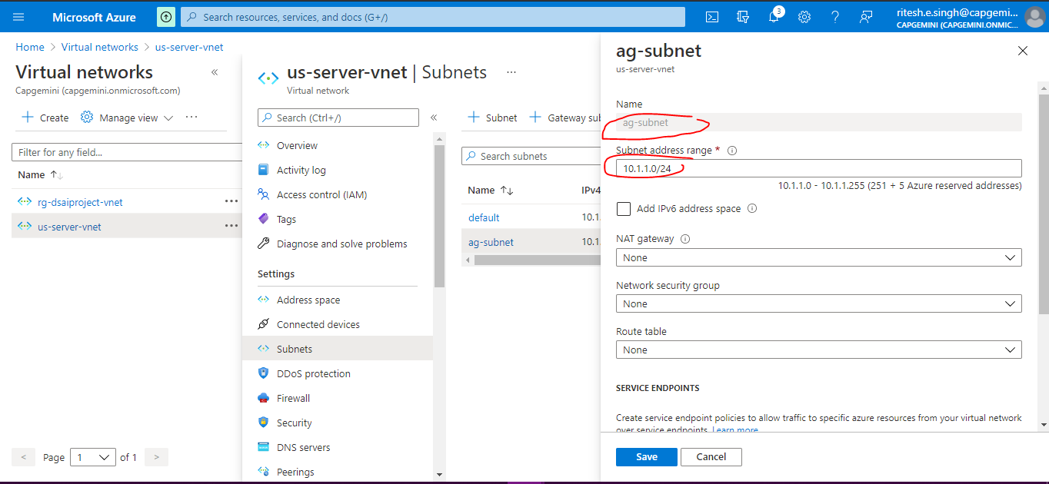

Now if you select virtual network and subnet it will not show error

Click **Next:Frontends>**

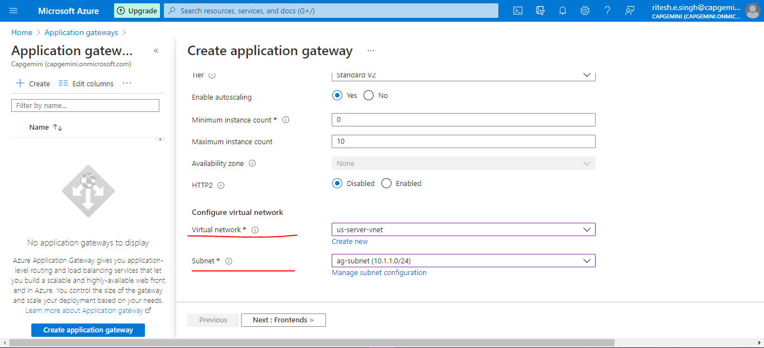

Add new and provide Name as shown below and click OK then Next:Backends

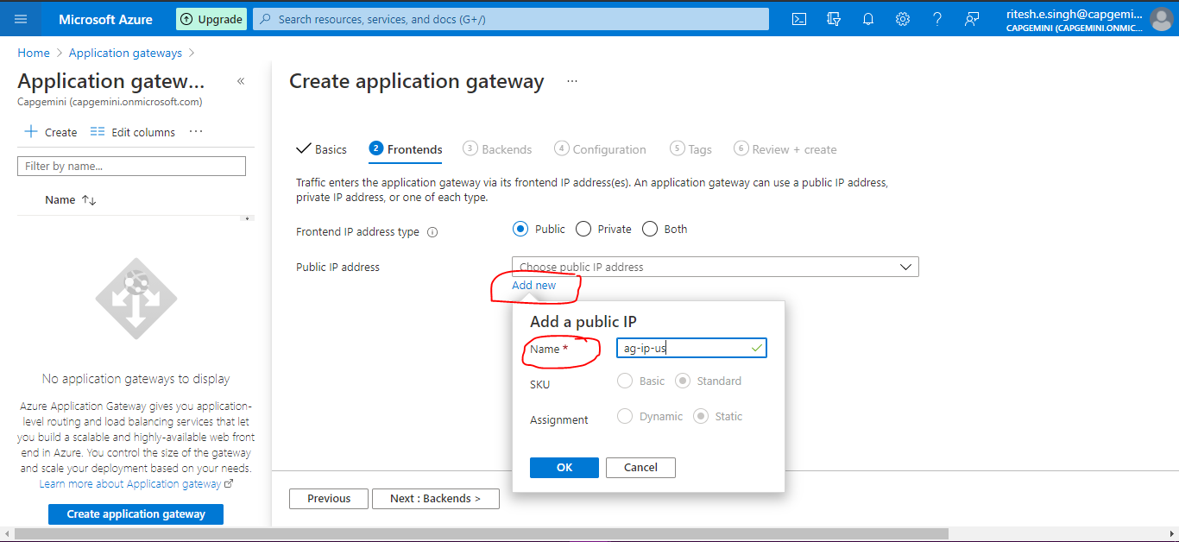

Click Add a backend pool

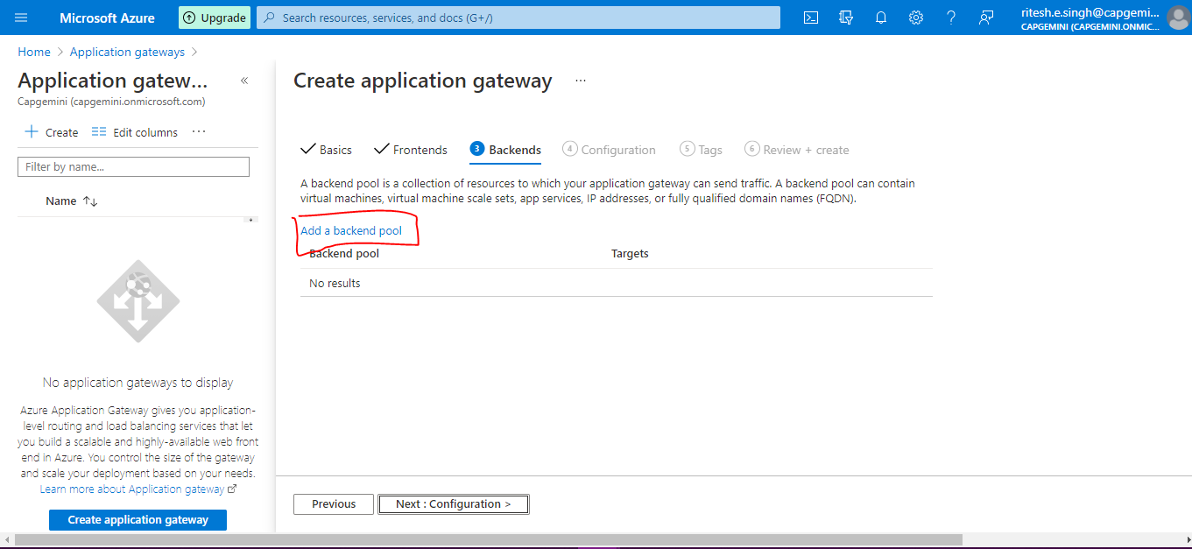

Provide details as follow click Add then click Next:Configuration

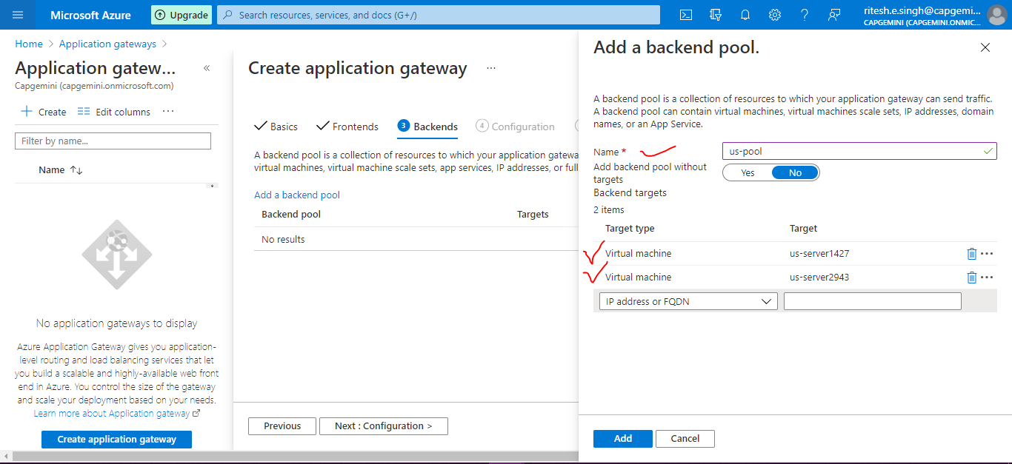

Click on +Add a routing rule

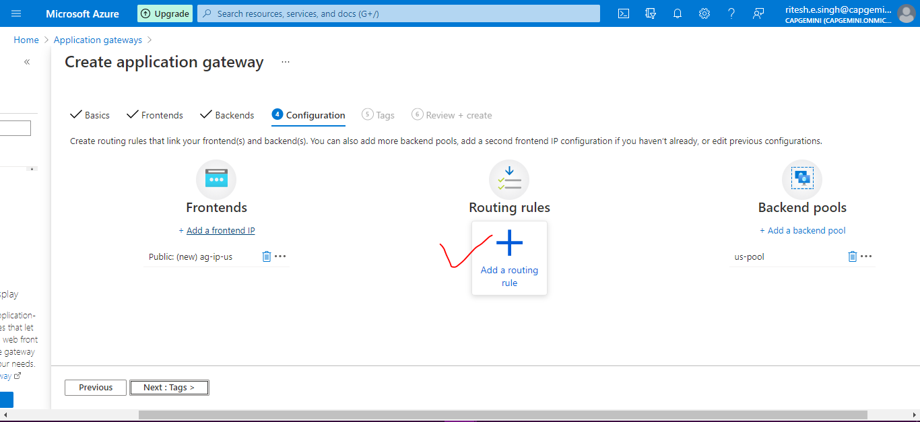

Add details in Listener tab then go to Backend targets

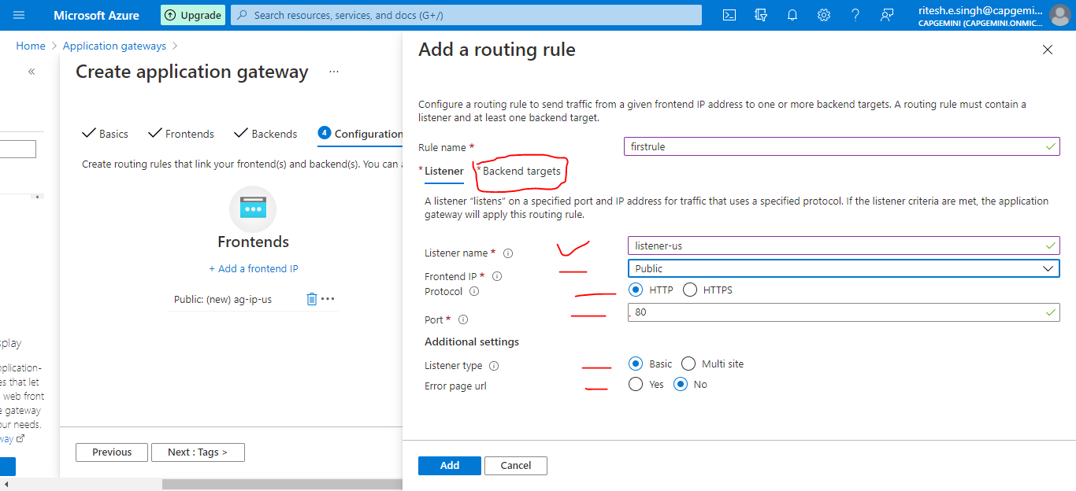

Provide details

For HTTP settings click Add new

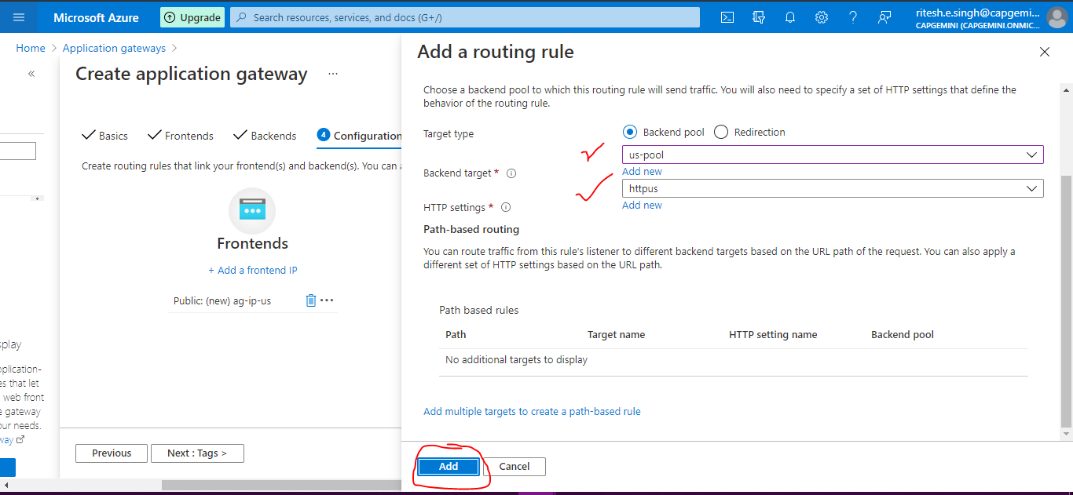

Add below HTTP setting and click **Add.** You will redirect back to Backend targets then click Add.

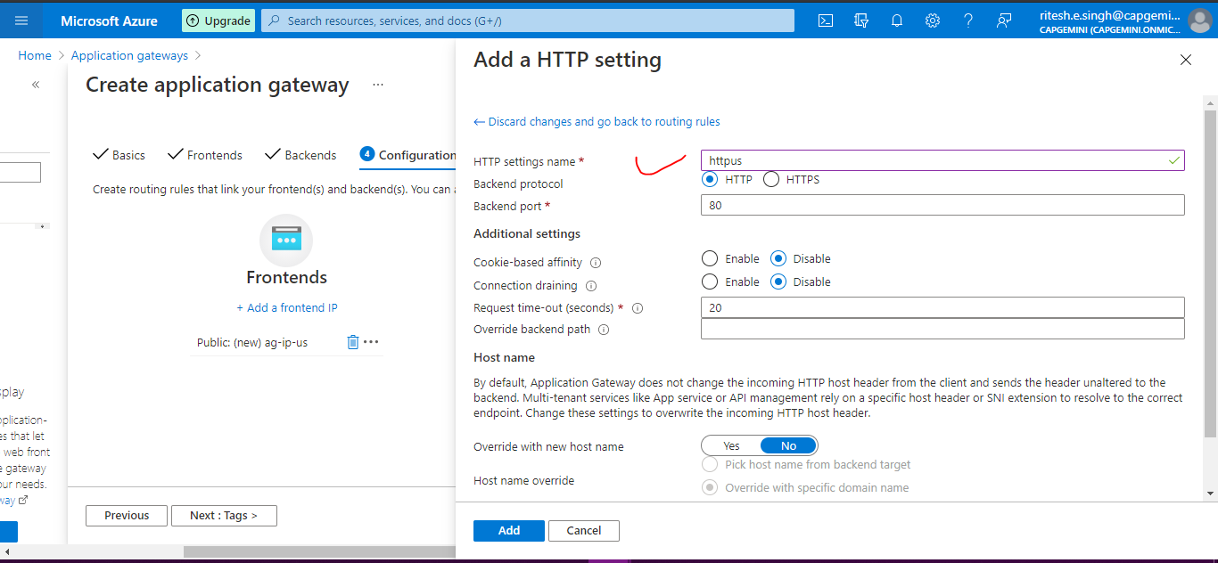

Keep default for **Tags** tab.

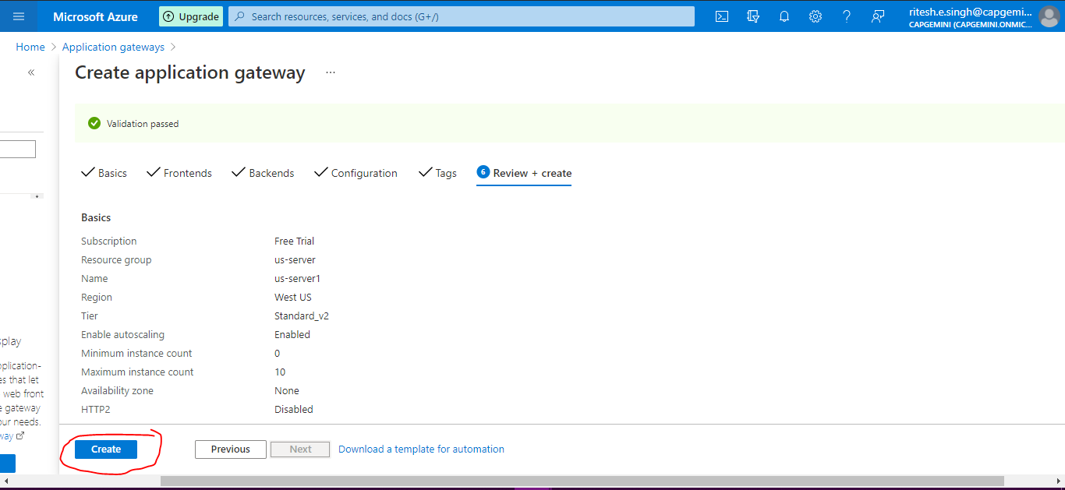

Similarly do subnet setting for resource group rg-dsaiproject which contains Indian server

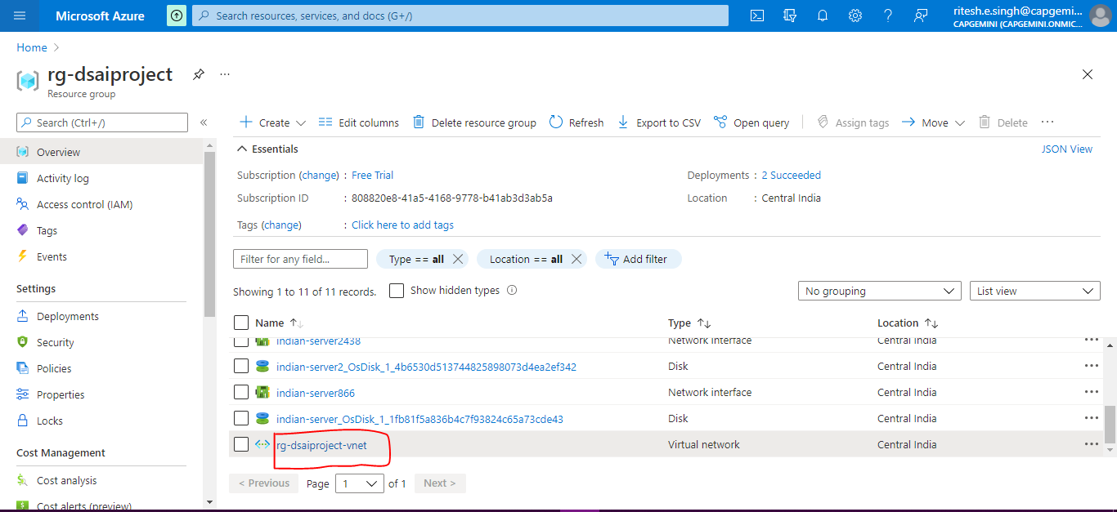

Click Subnet under settings and then click +Subnet

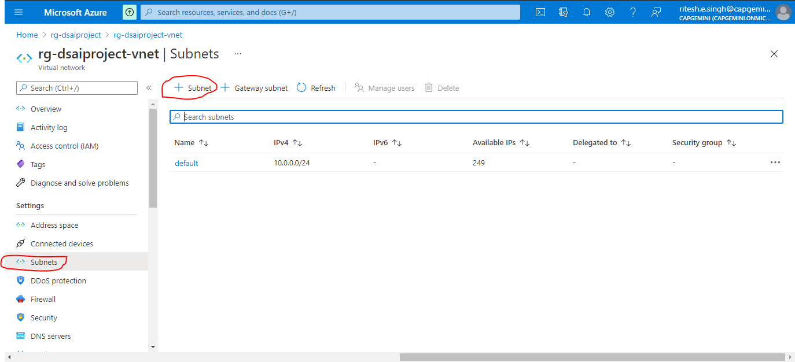

Provide name and click Save

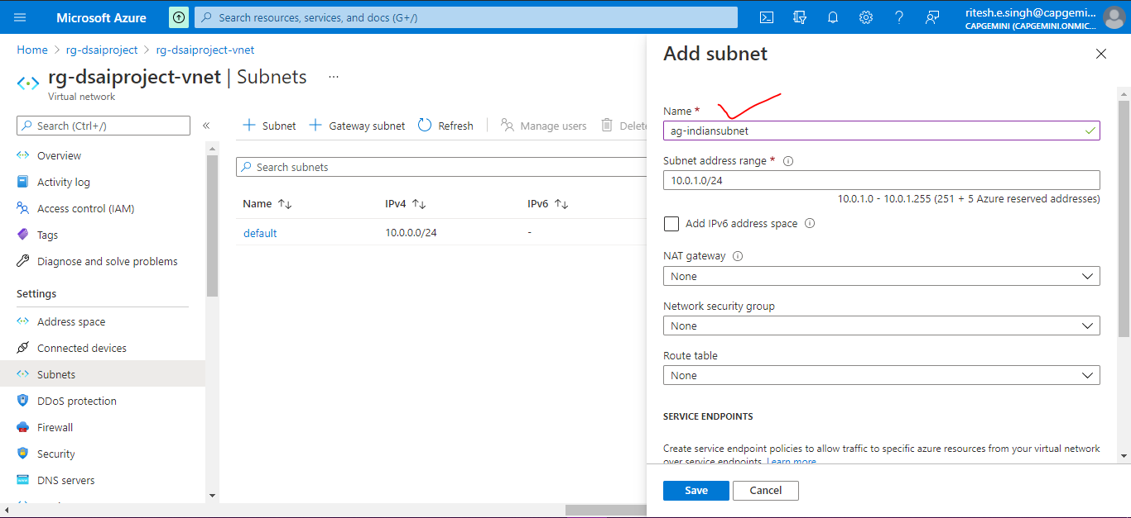

Now go to Application gateways

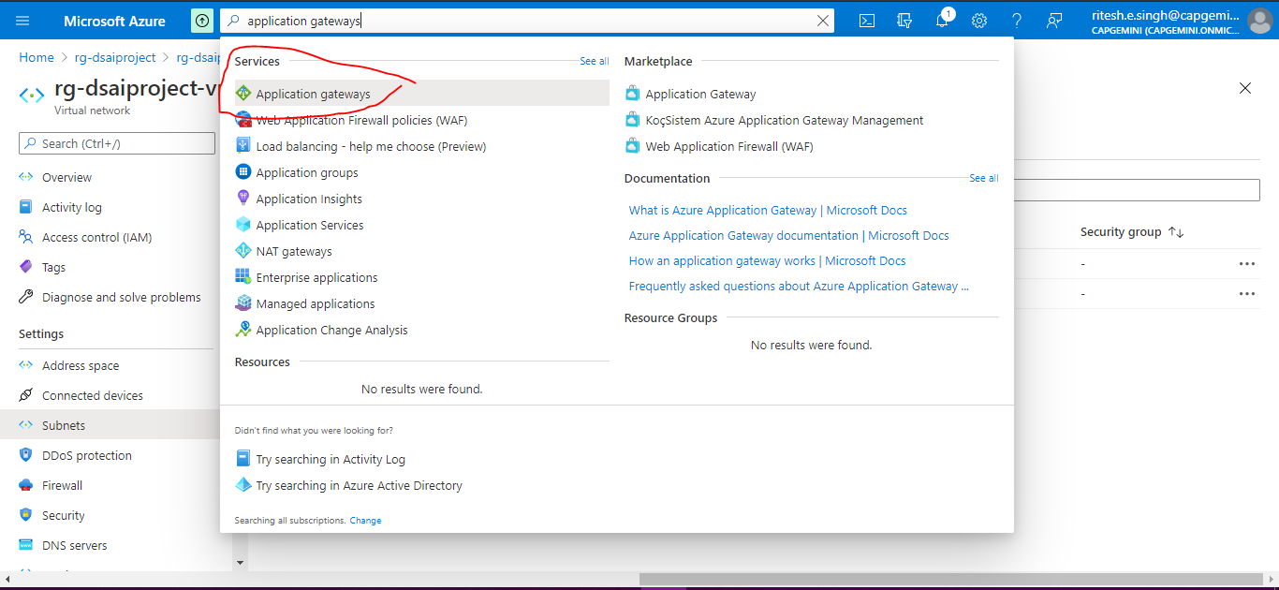

Click +Create

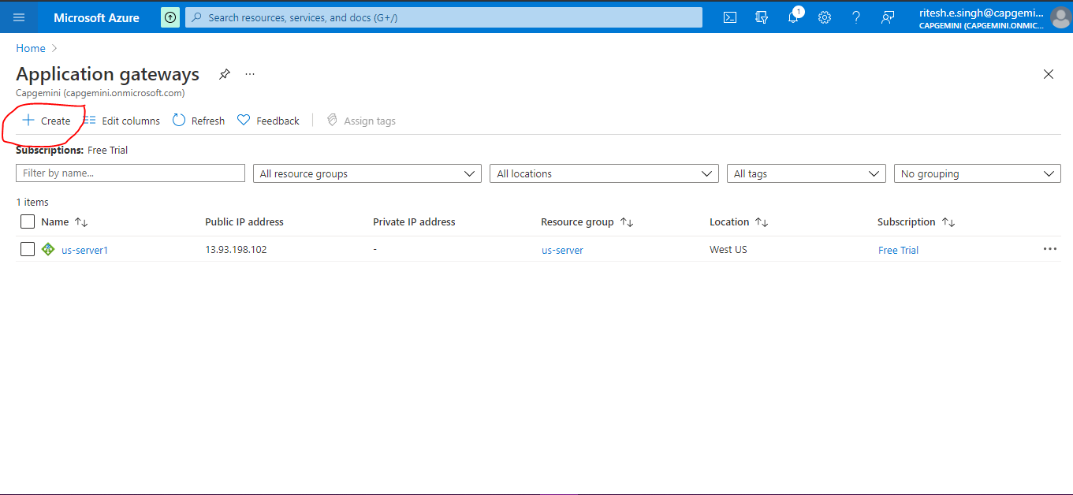

Provide below details and click Next:Frontends

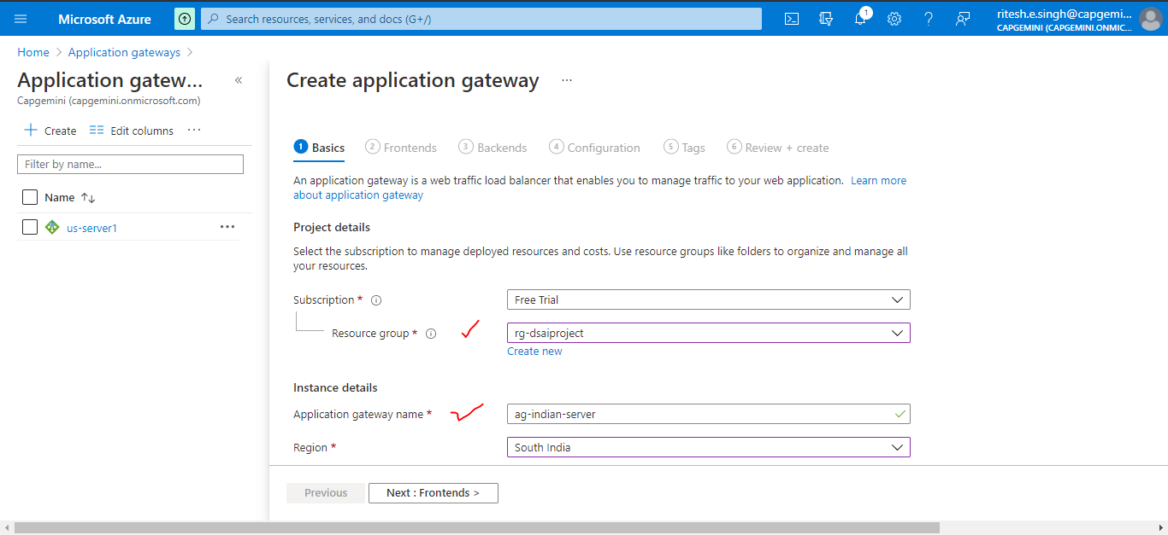

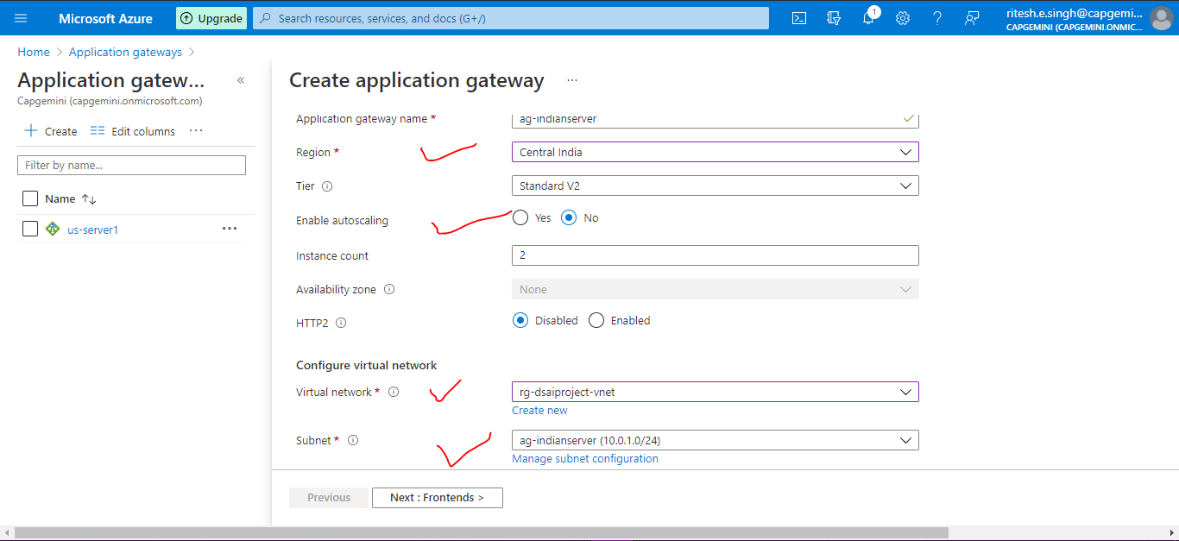

In Frontends, click Add New and add Name as shown below and click Next:Backends>

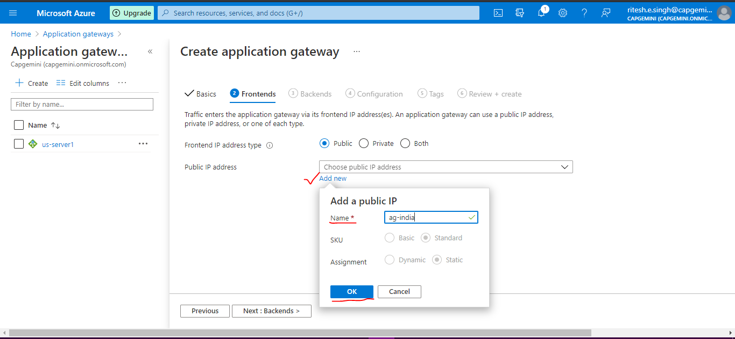

In Backends, click on Add a backend pool and then add details as shown below and click Add

Then Next:Configurations>

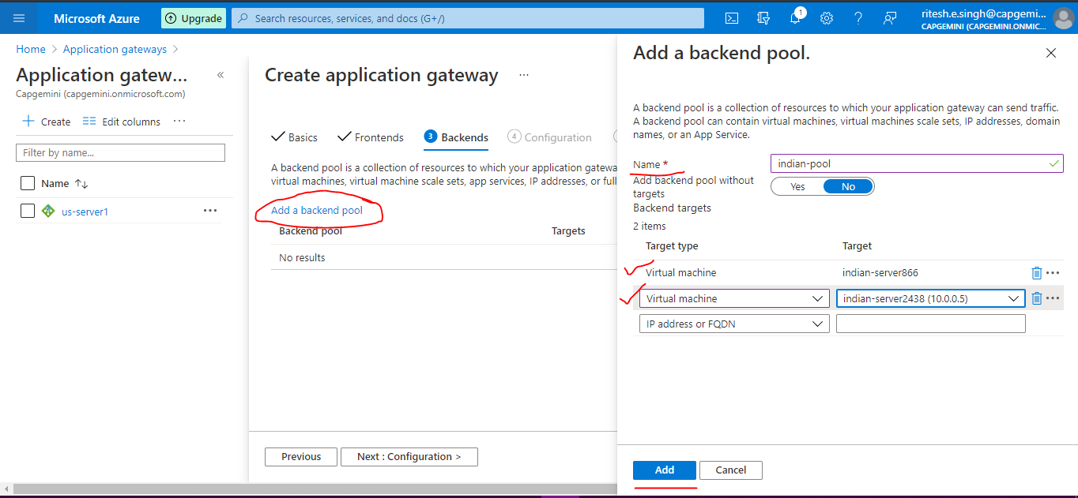

Click on + as shown below

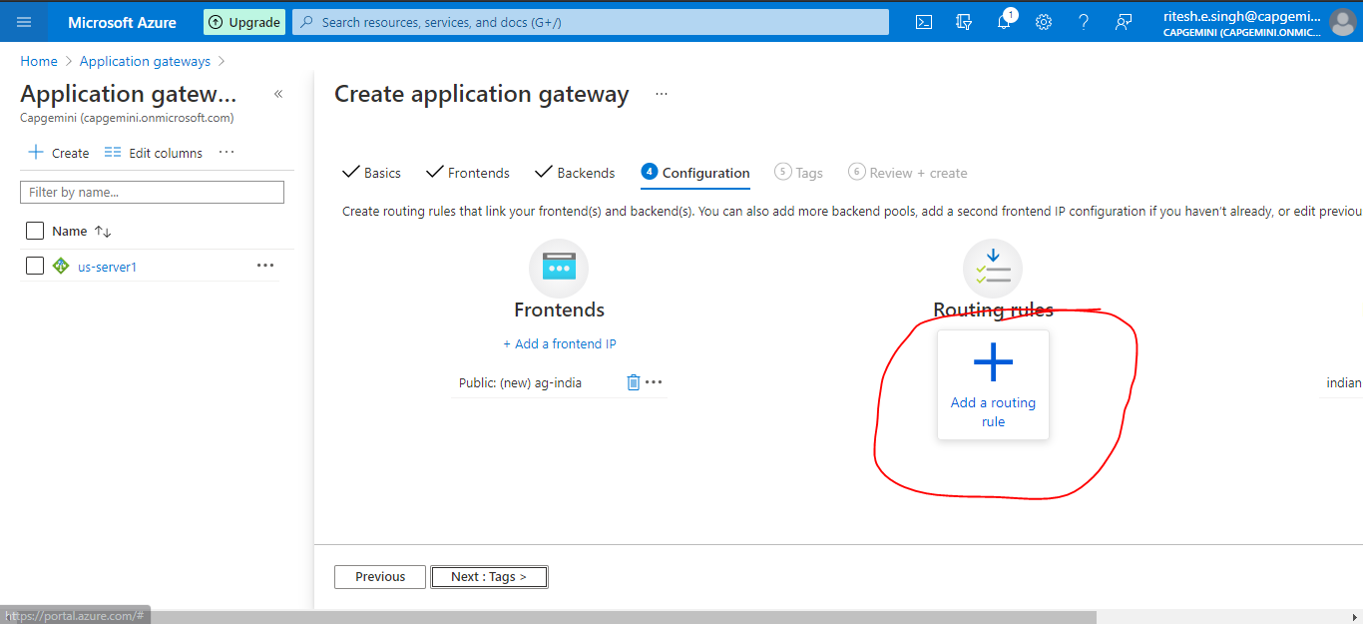

Add a routing rule details for Listener tab

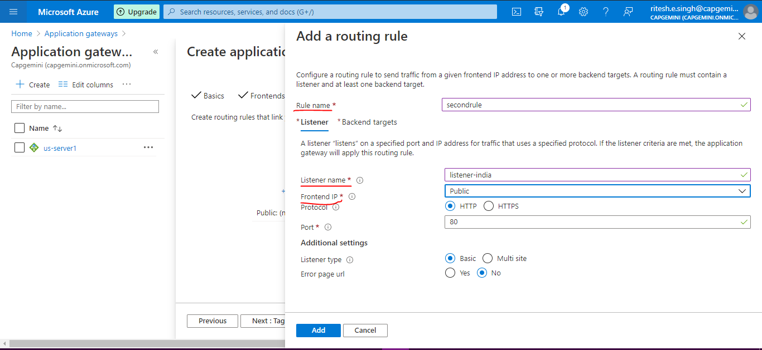

Add a routing rule for Backend targets

For HTTP settings click Add new

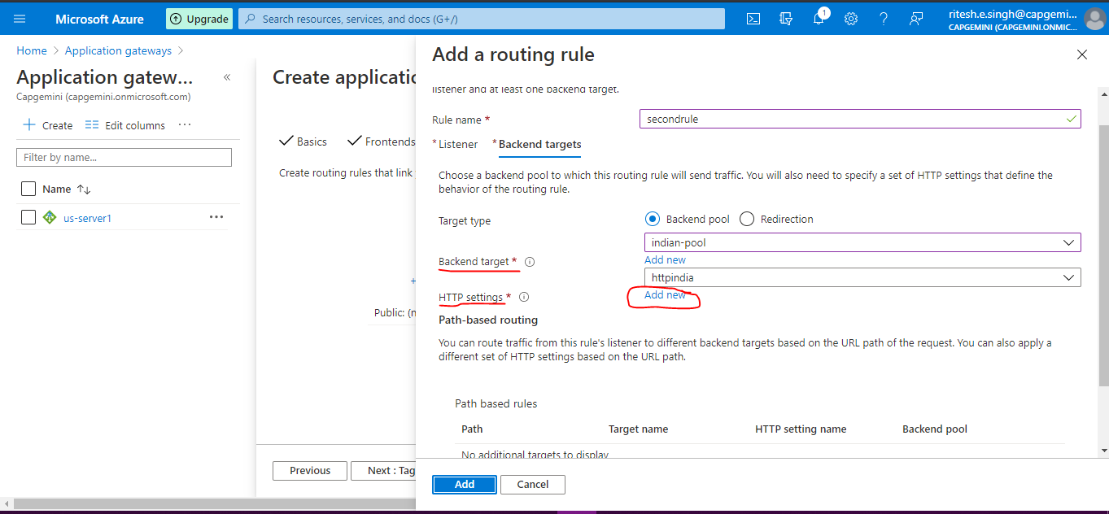

Add a HTTP setting details

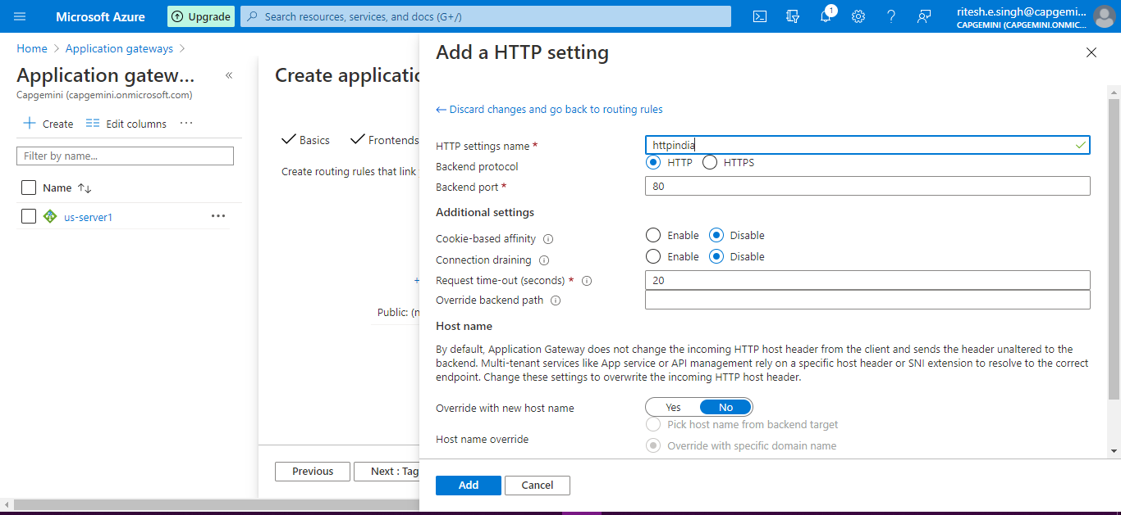

Click Next:Tags>

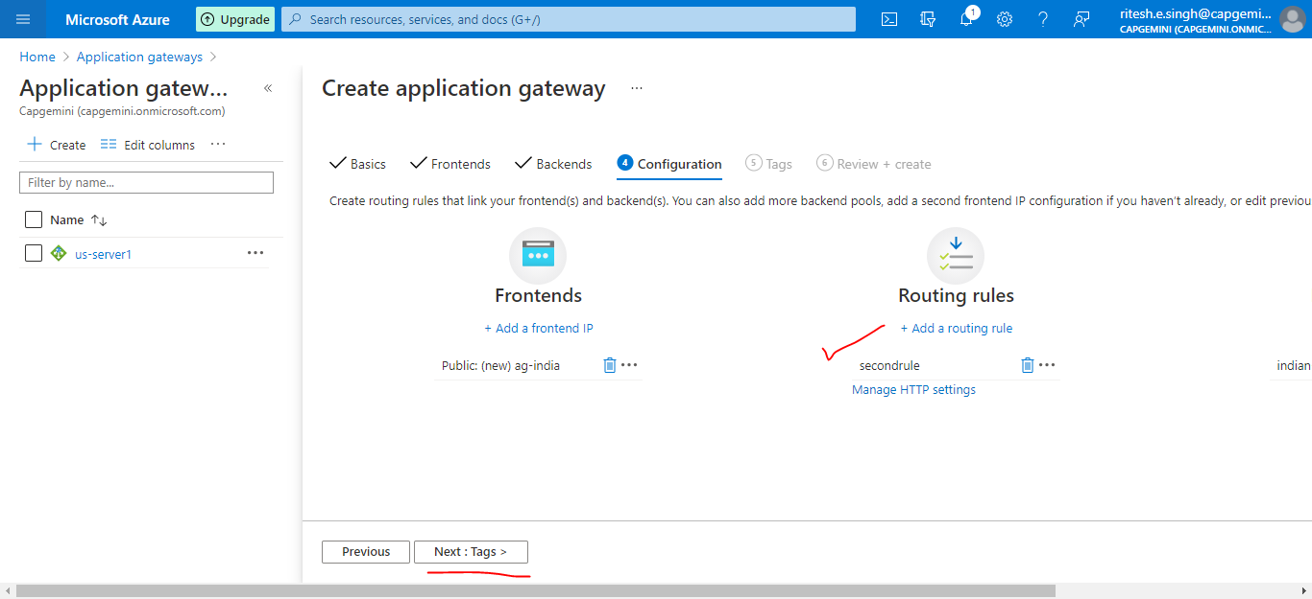

Default for Tags click Next:Review + Create>

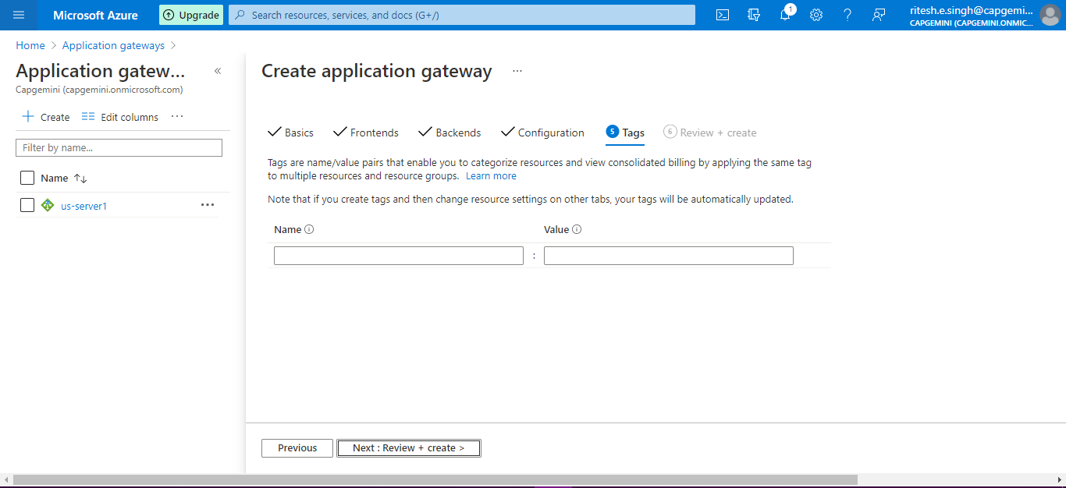

Validation passed click on Create

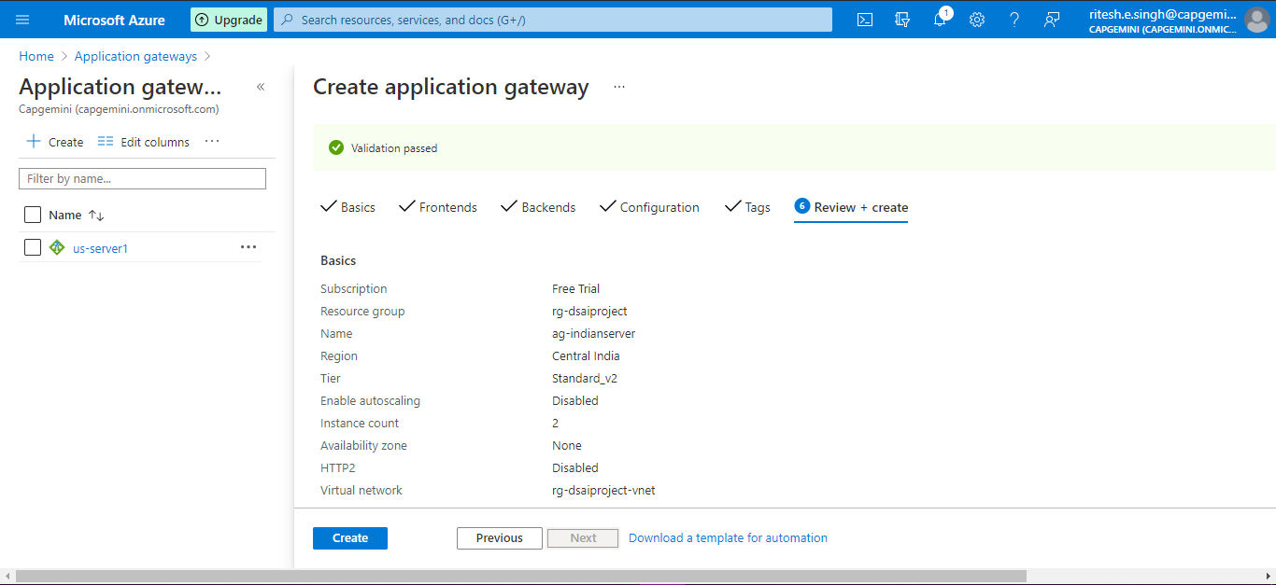

Check our application gateway is working fine or not

Go to Resource group i.e us-server then click in us-server1 application gateway

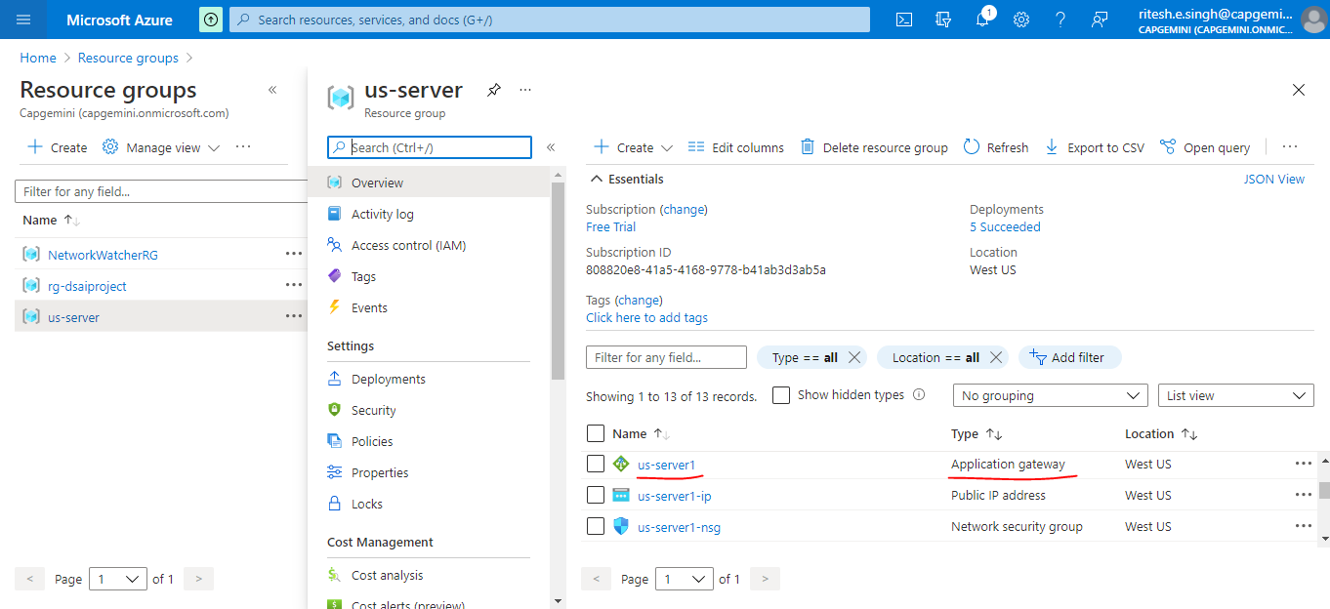

Copy the Frontend public IP address and paste on browser

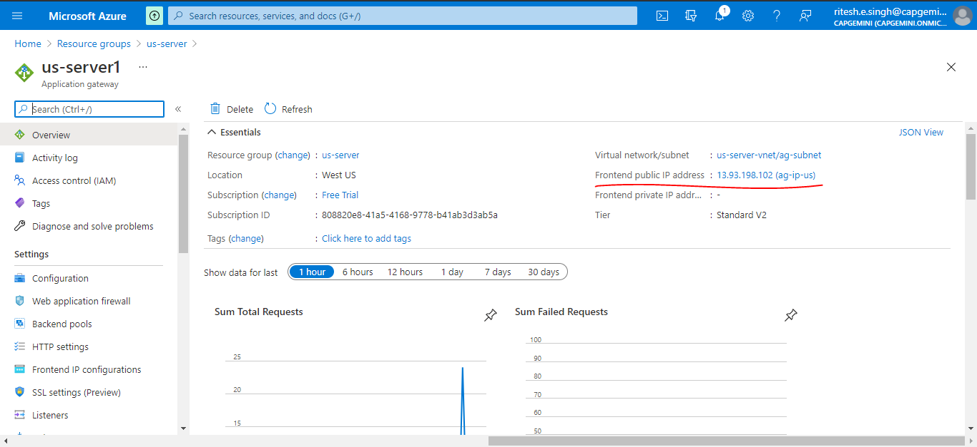

Now you can see through single IP 13.93.198.102 it is redirecting to both us server i.e us-server1 and us-server2

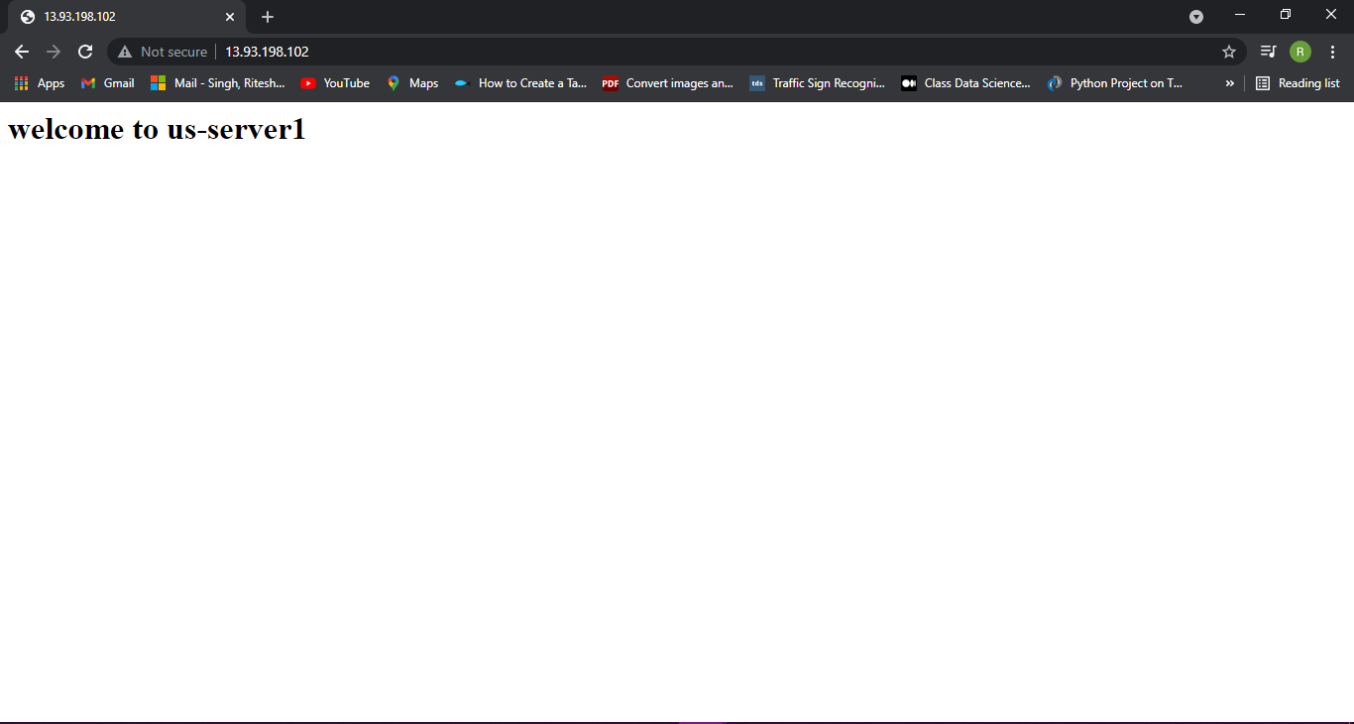

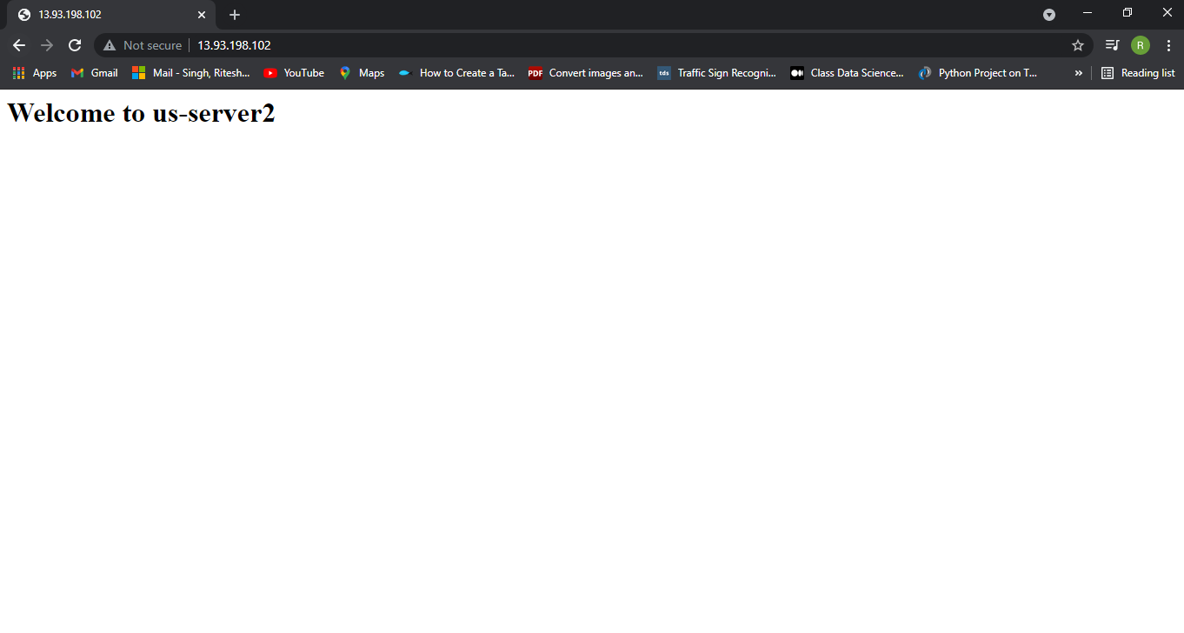

**Similarly you can see for indianserver as well.**

Now we will add a Traffic Manager profiles

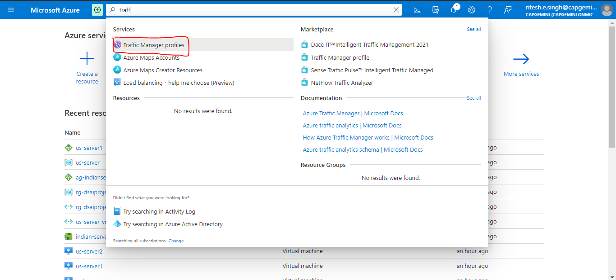

Click on +Create

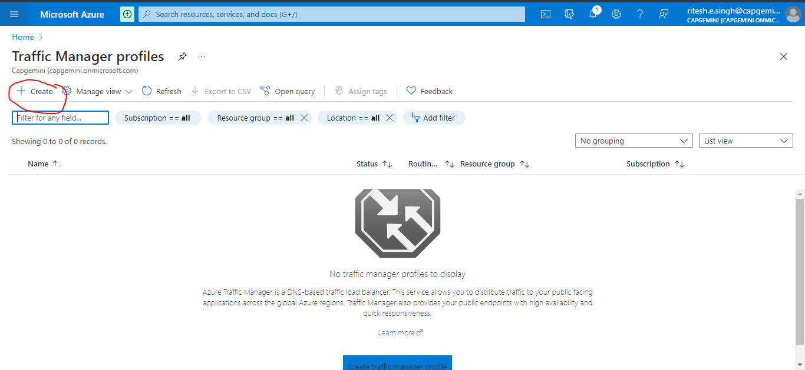

Add details to create Traffic Manager profile

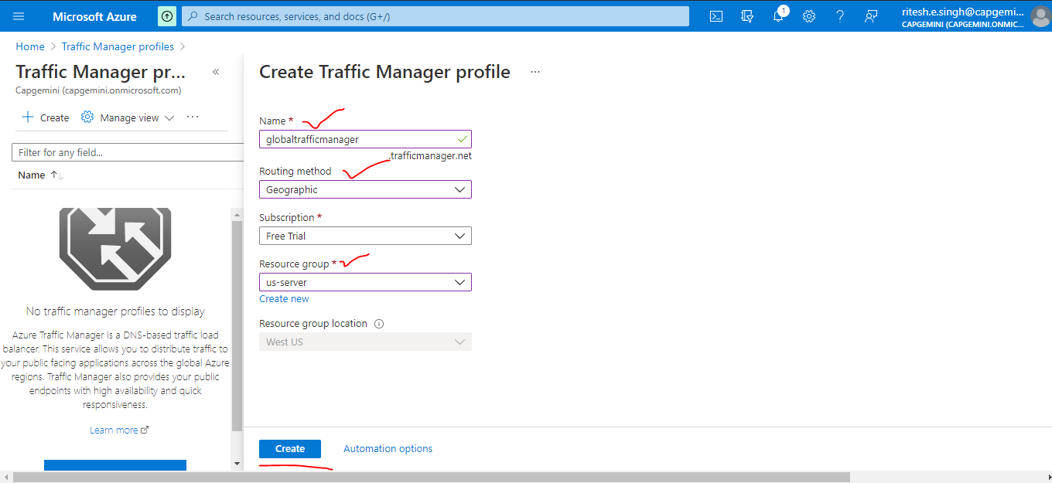

Click globaltafficmanager

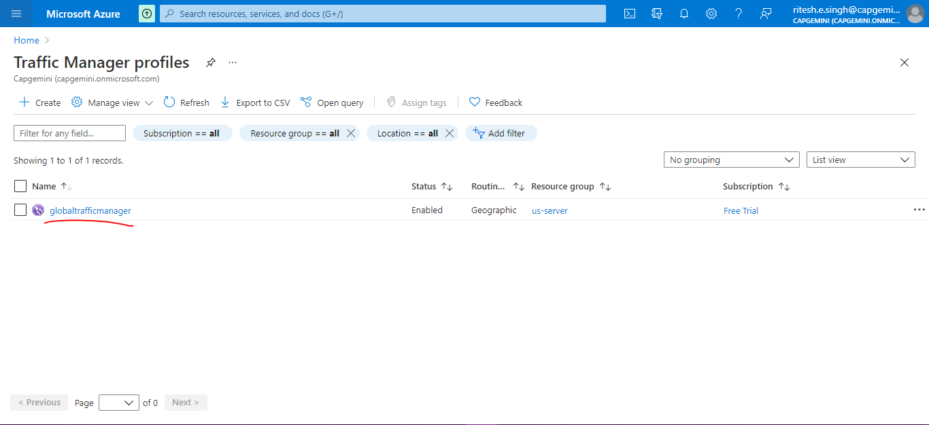

Go to Configuration and check it everything is fine

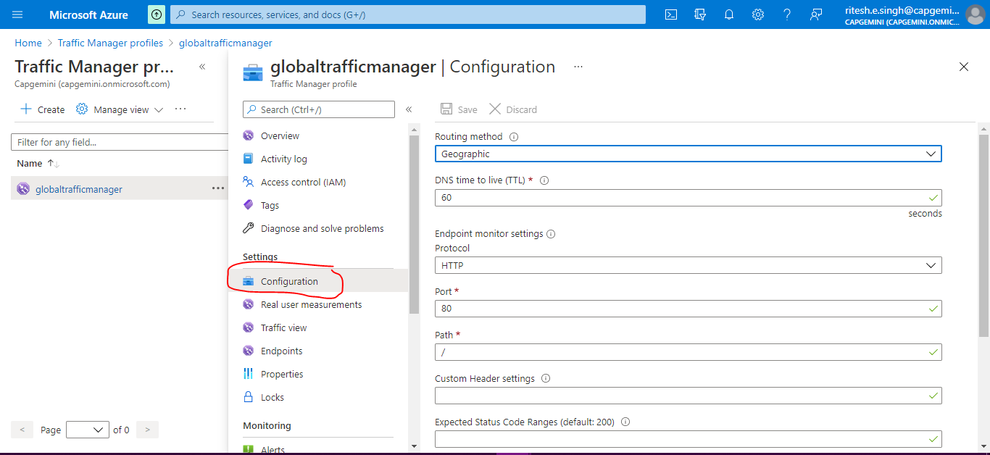

Now go to Endports and click on +Add

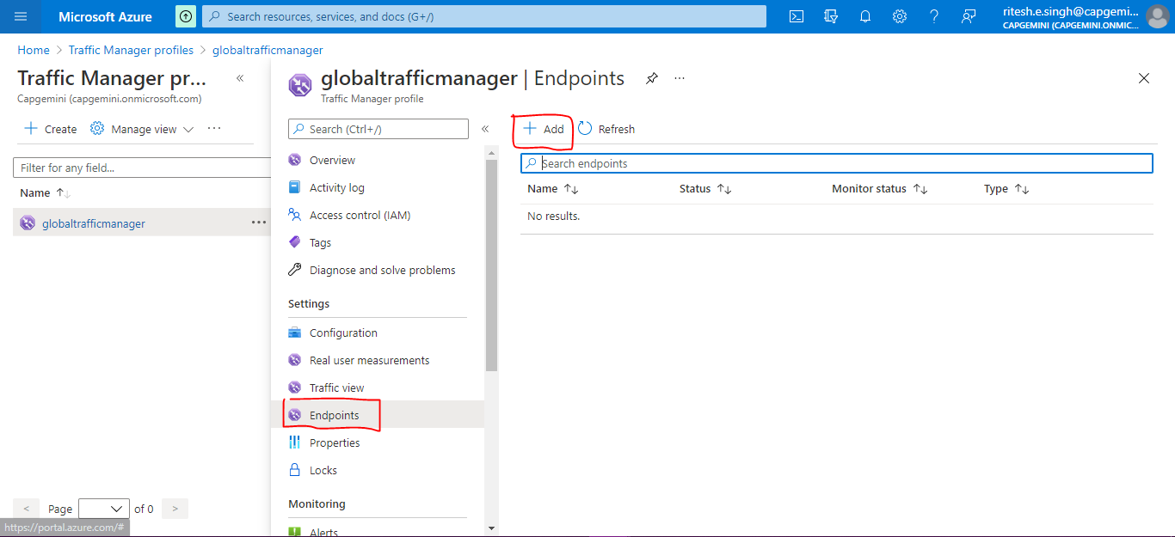

Add details but it will show No DNS name is configured for Public IP address

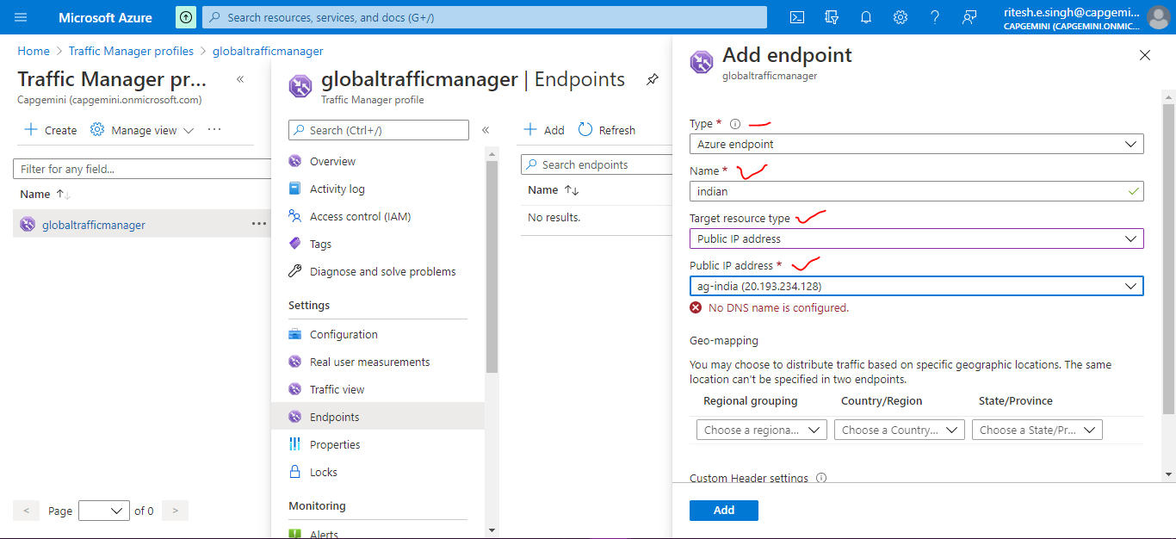

So for that go to Public IP addresses

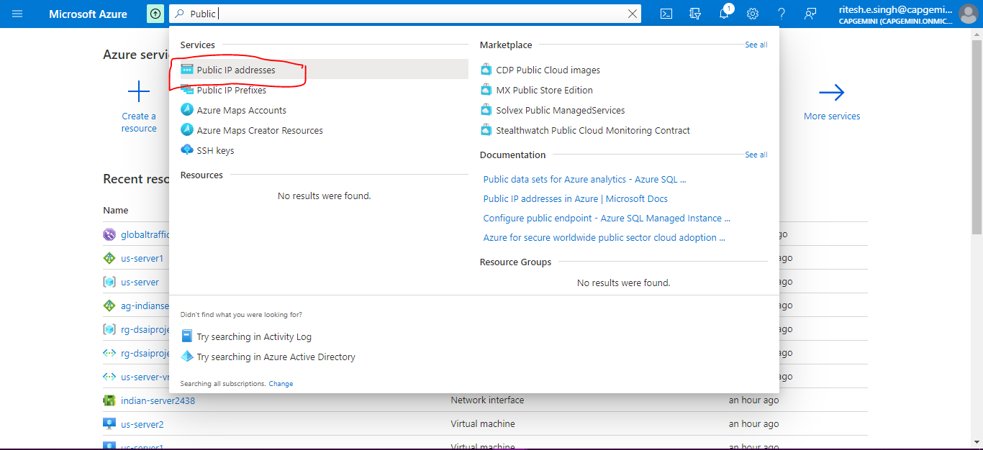

Go to ag-india

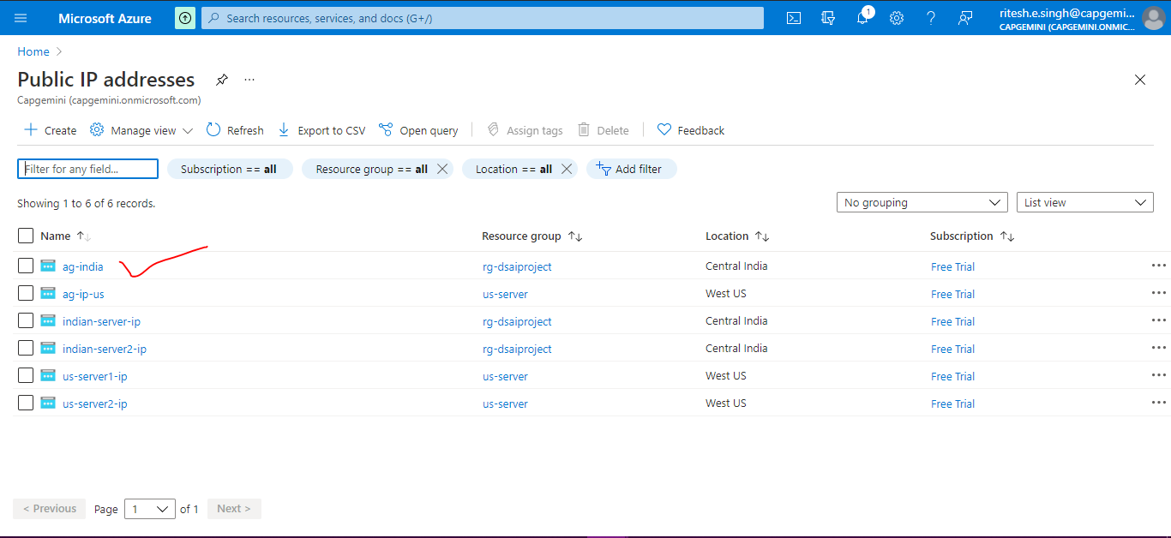

Go to Configuration and provide the DNS name and click Save

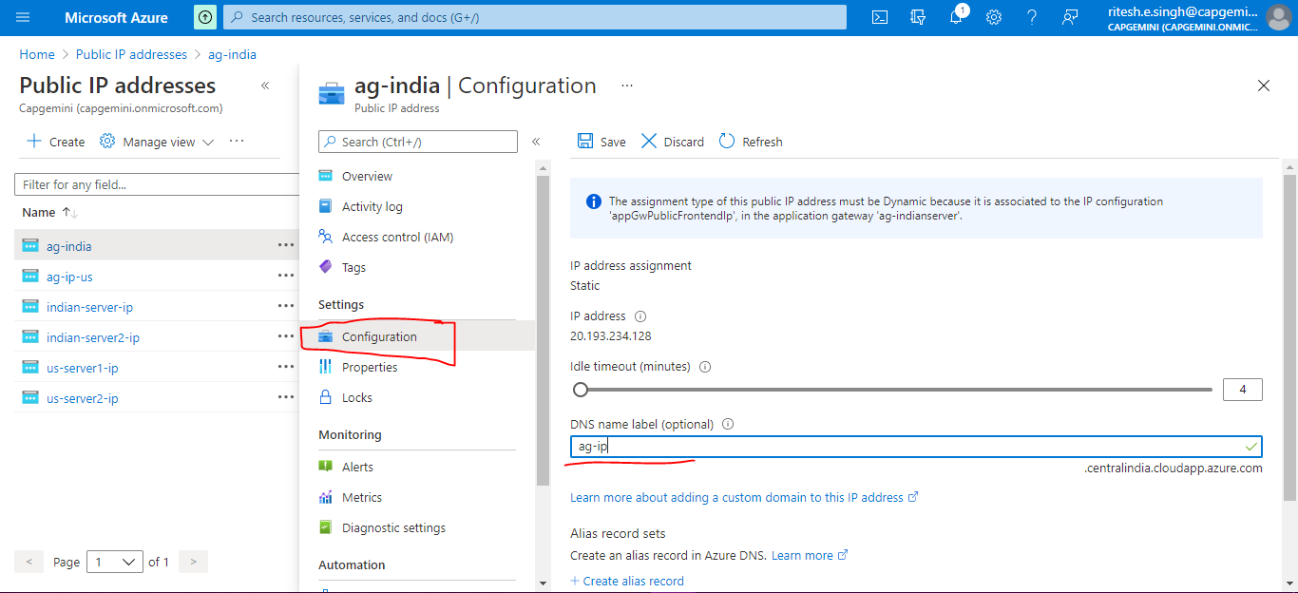

go back to endpoint settings for globaltrafficmanager (error will be gone)

add geo mapping and click Add

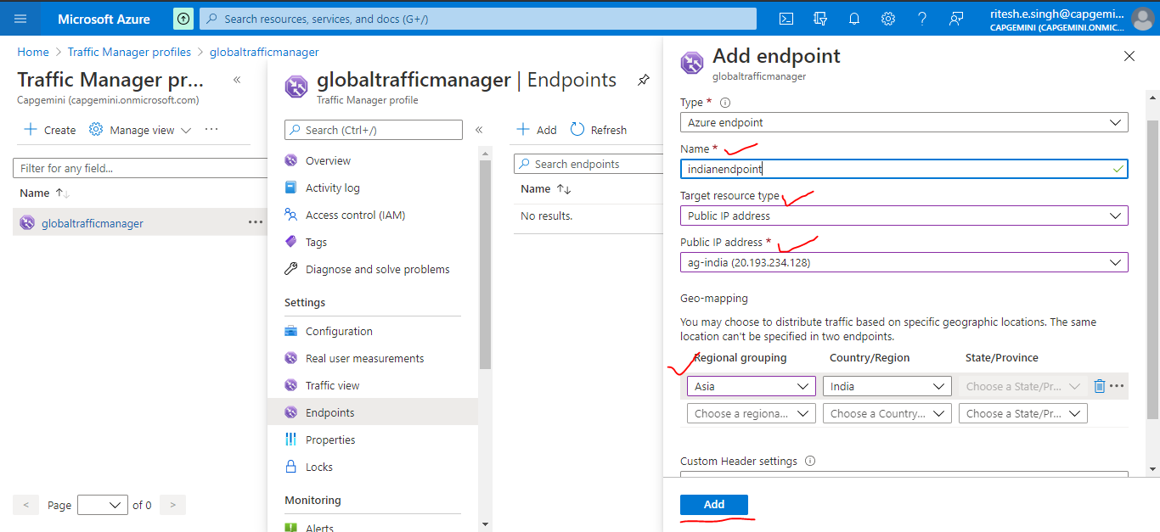

Go to Overview and copy DNS name and paste on browser

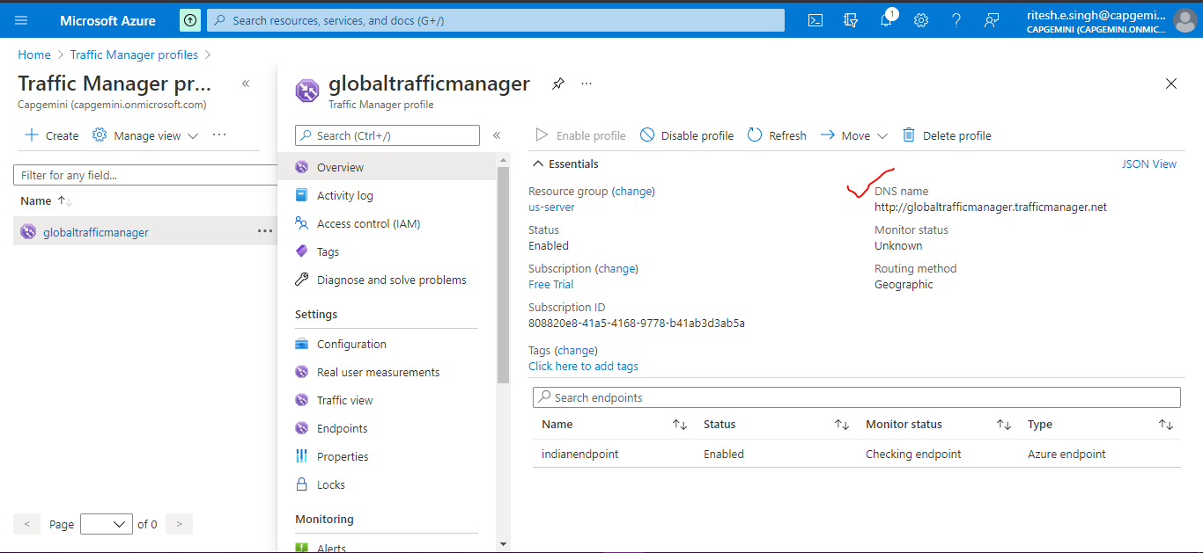

Routing to both server

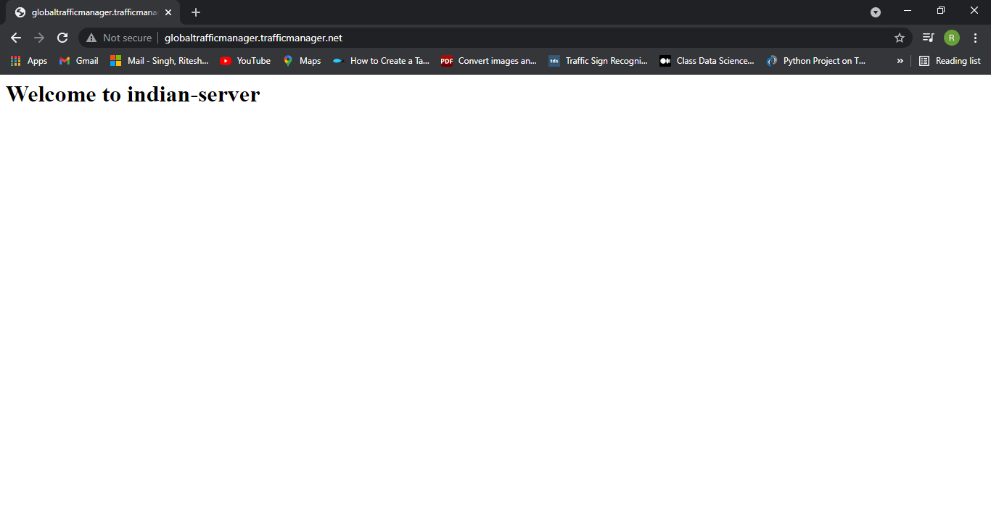

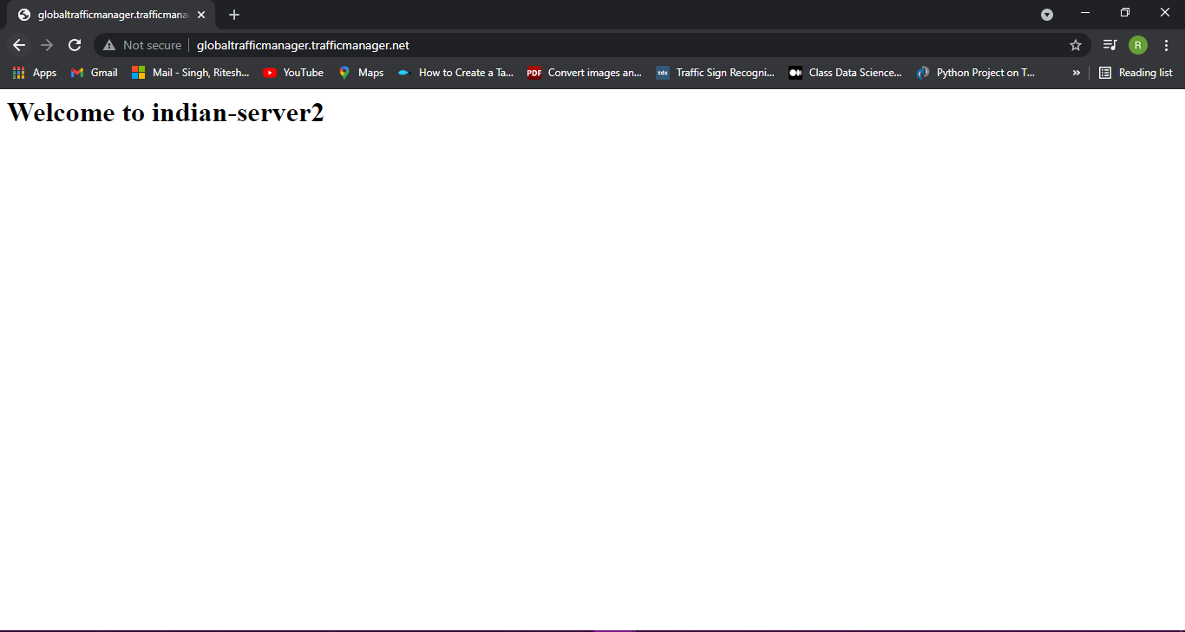

Go to DNS zones

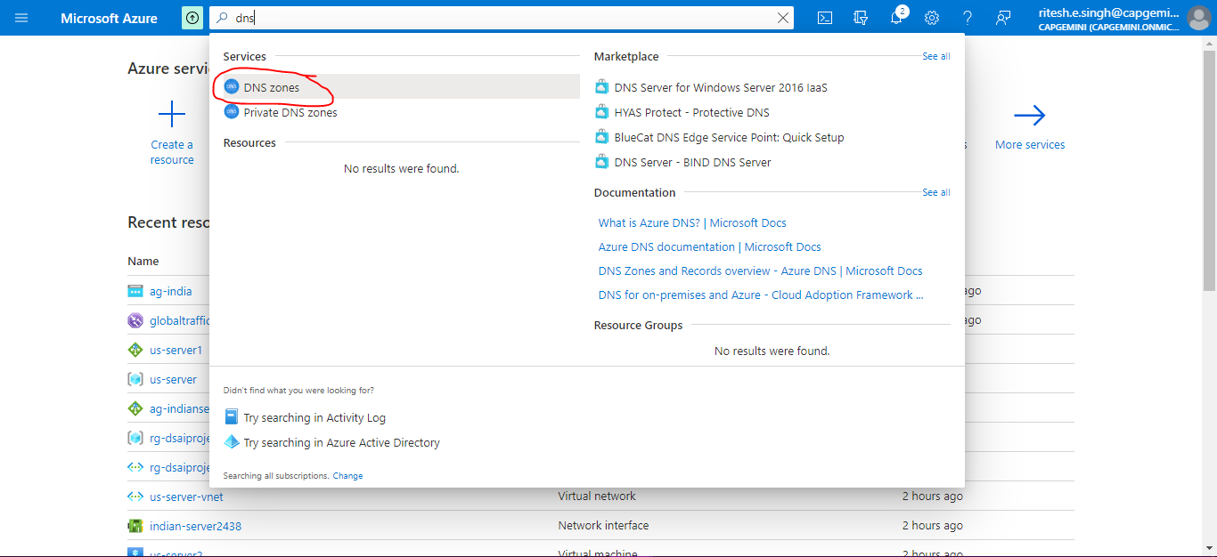

Go to Freenom.com on browser (it provides free domain) and sign in



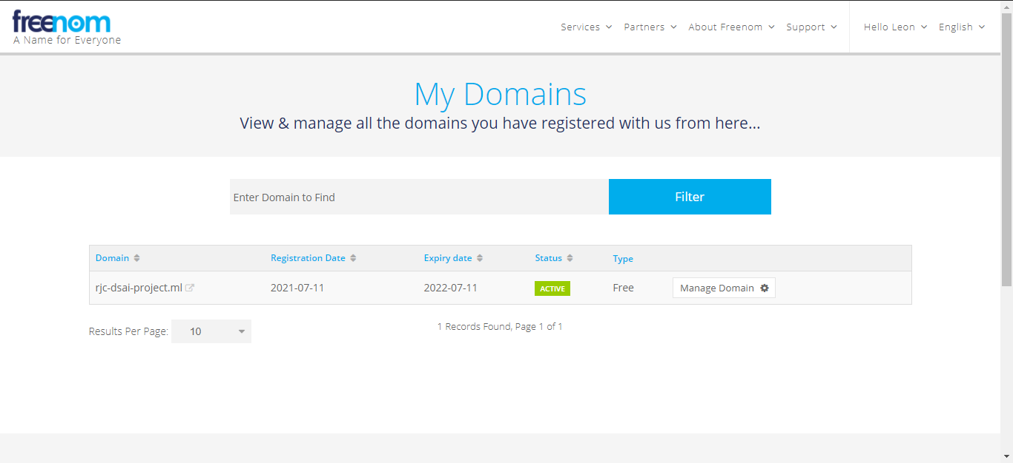

Click +Create

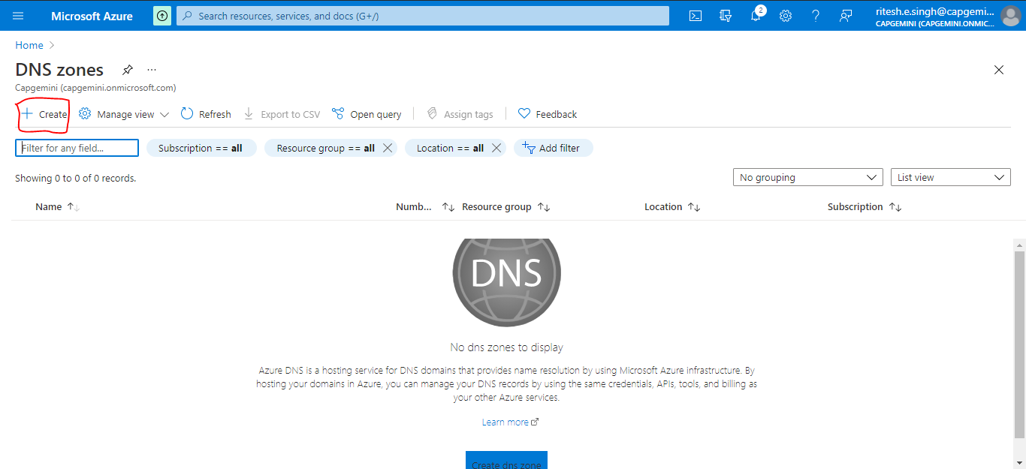

Provide details in name provide the domain which you created on freenom.com and click Review+Create

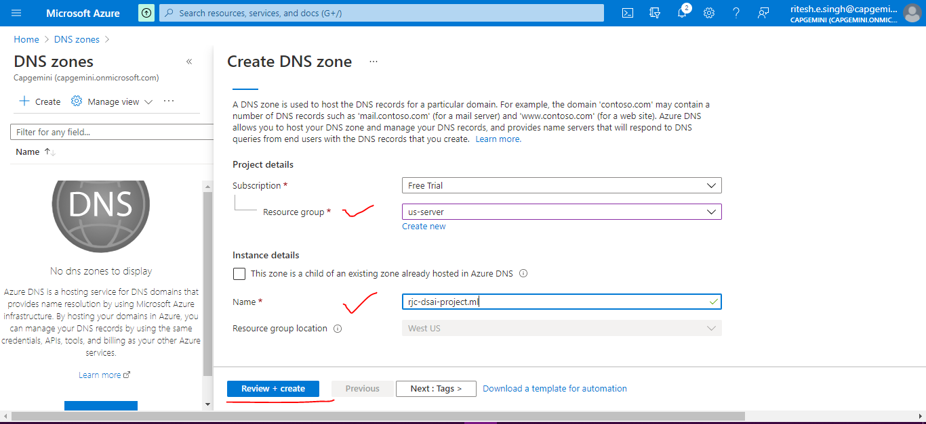

Validation passed click Create

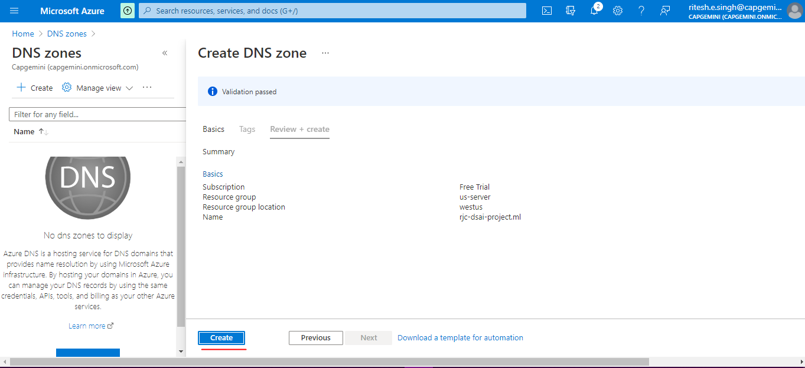

Deployment is complete click on Go to resource button

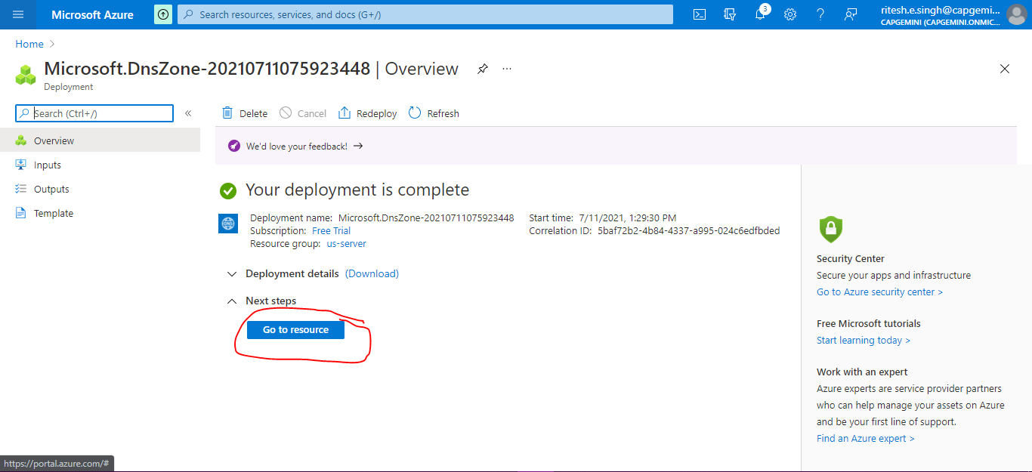

Four values are provided just click on it

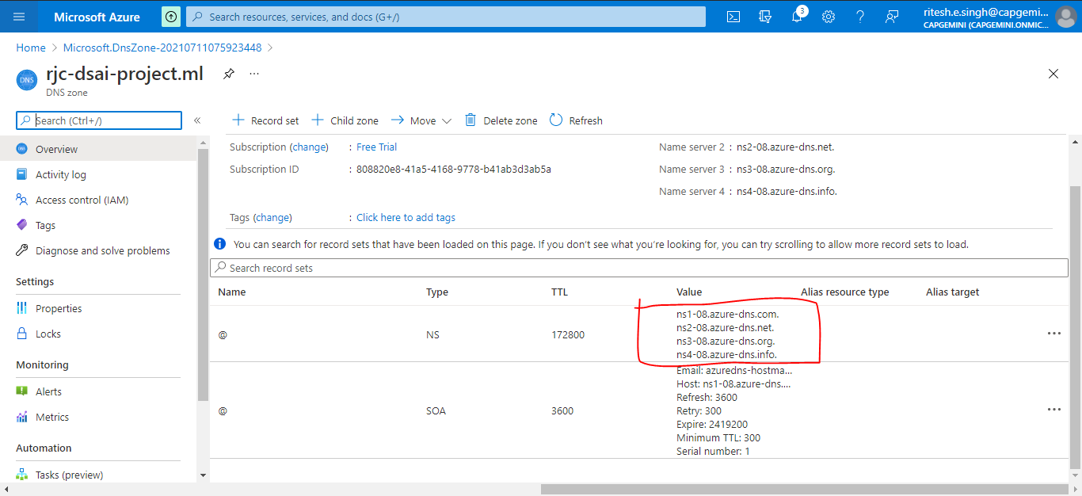

Copy one by one

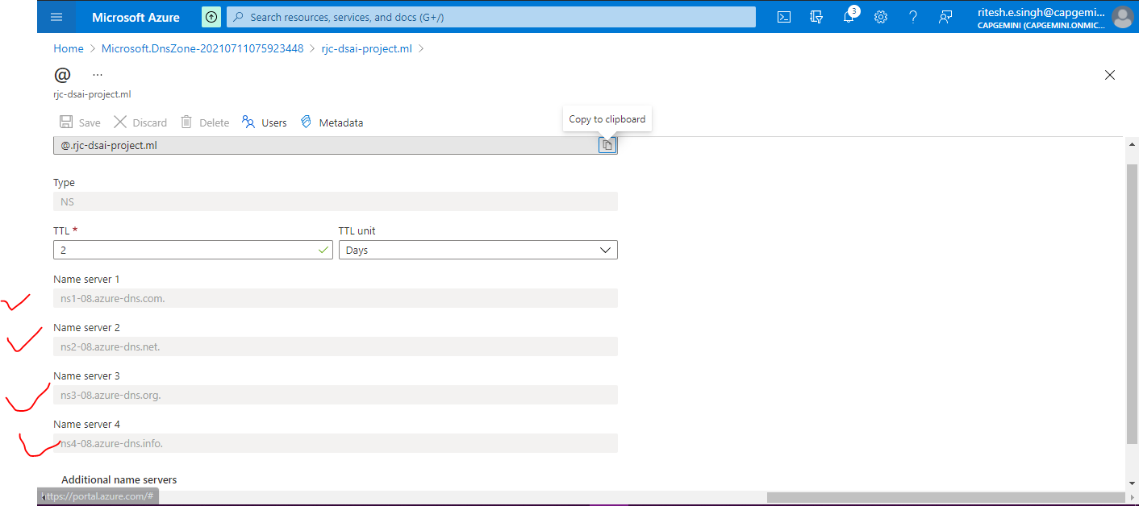

Go to freenom Click on Manage domain

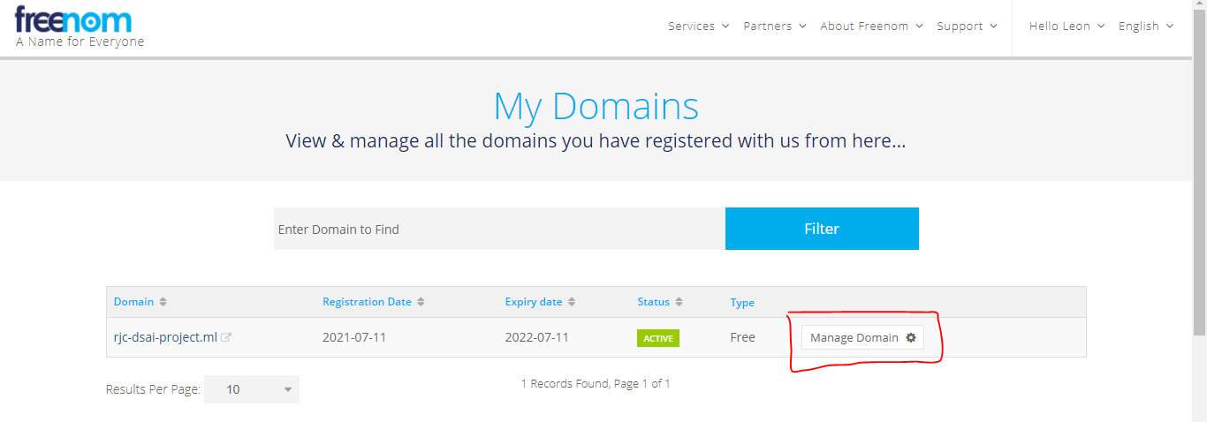

Go to Management tools and click on Nameservers

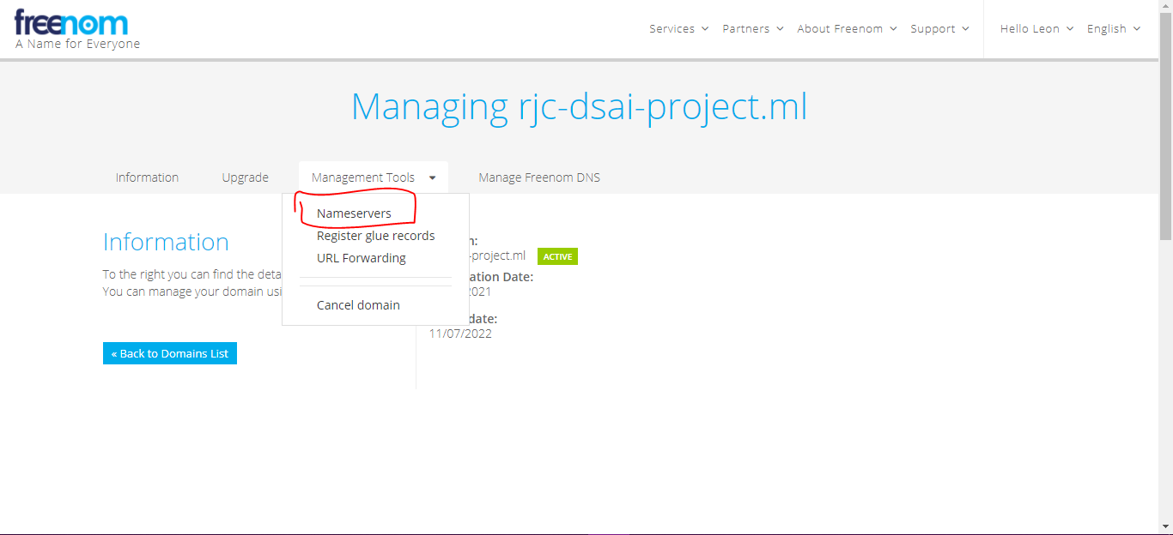

Select use custom nameservers and paste the values one by one in respective namserver and click on Change Nameservers

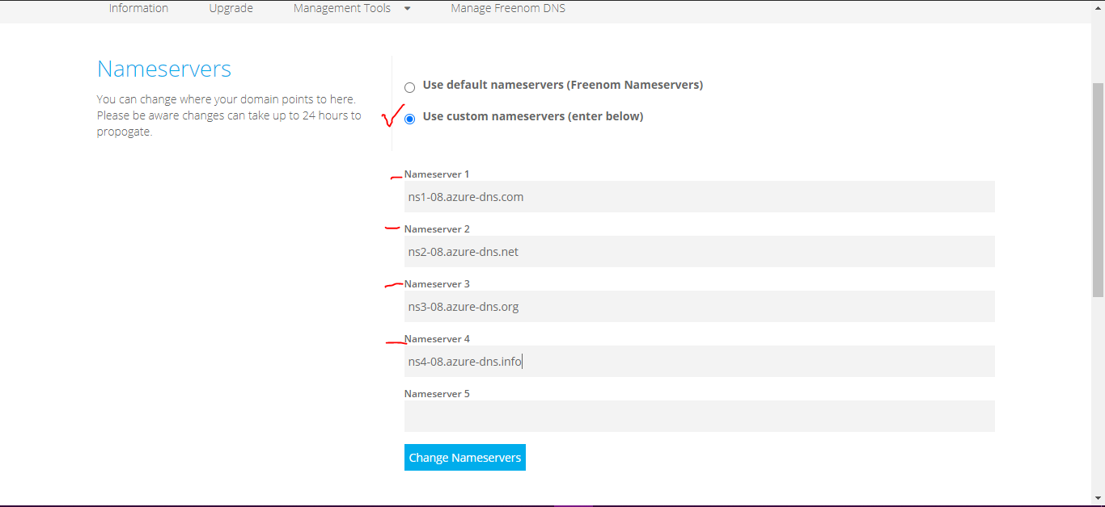

Go to below DNS zone and click on Record set

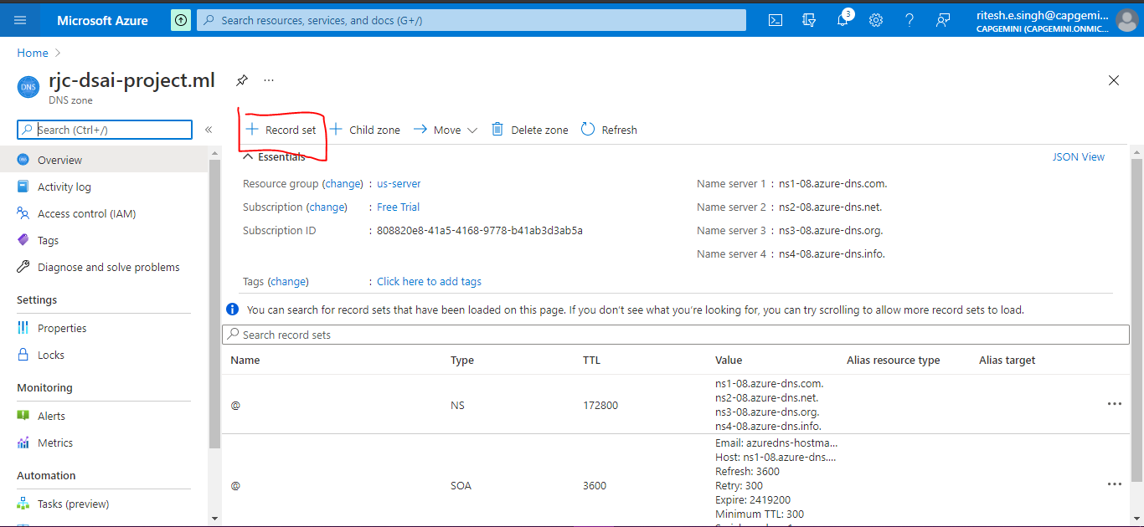

Add record set details

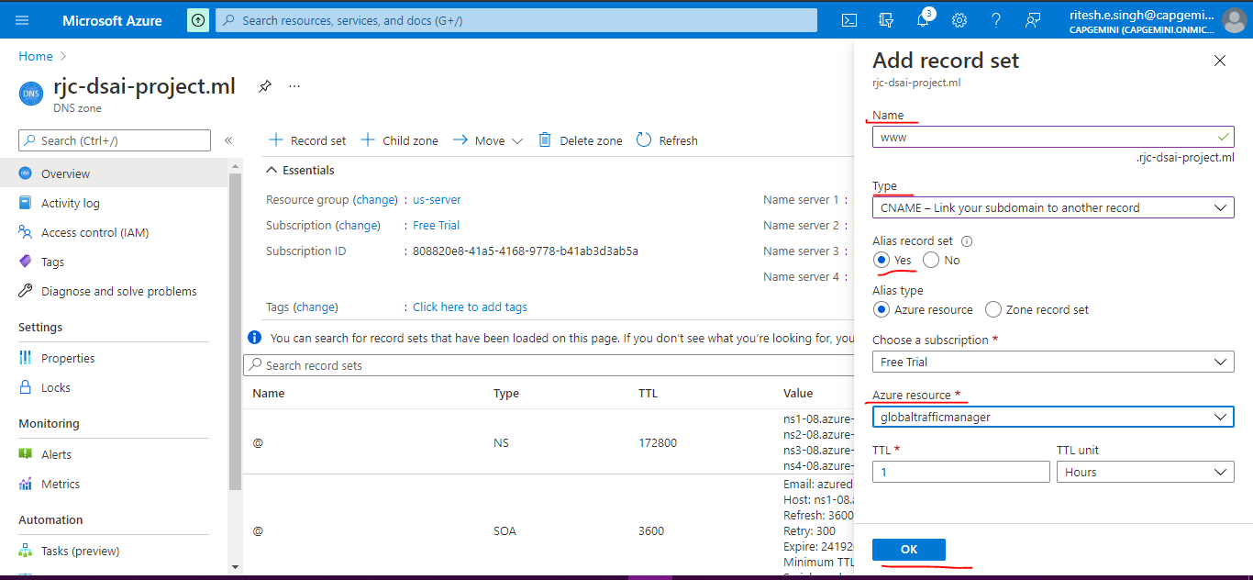

Provide dns name for us server application gateway IP address also and click save

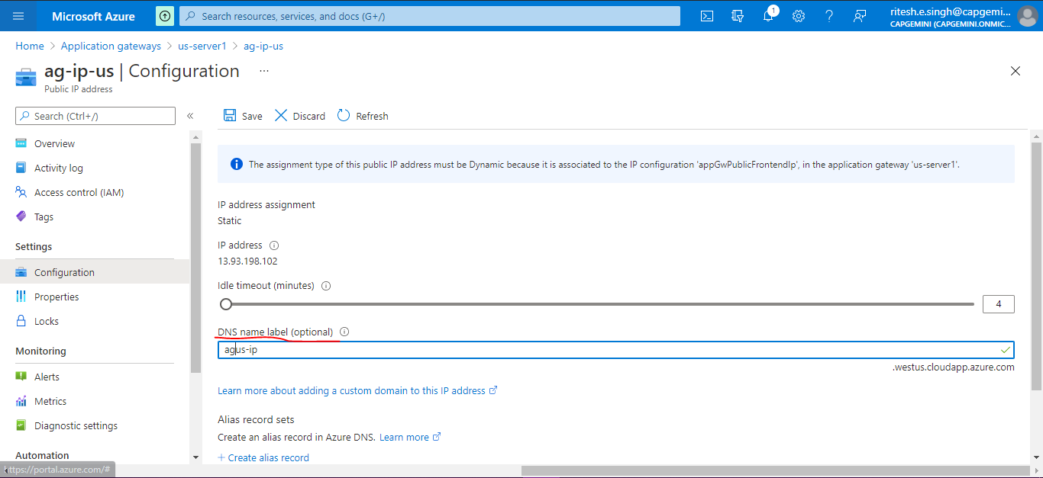

Add endpoint (Traffic manager profiles for us server)

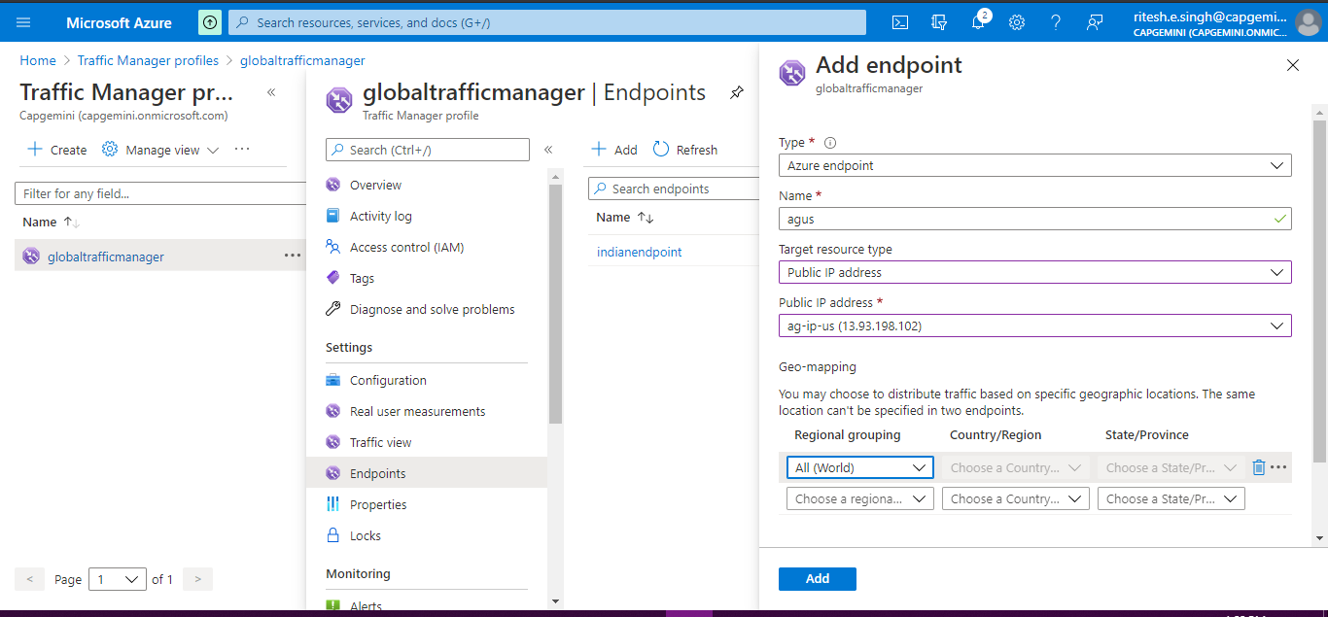

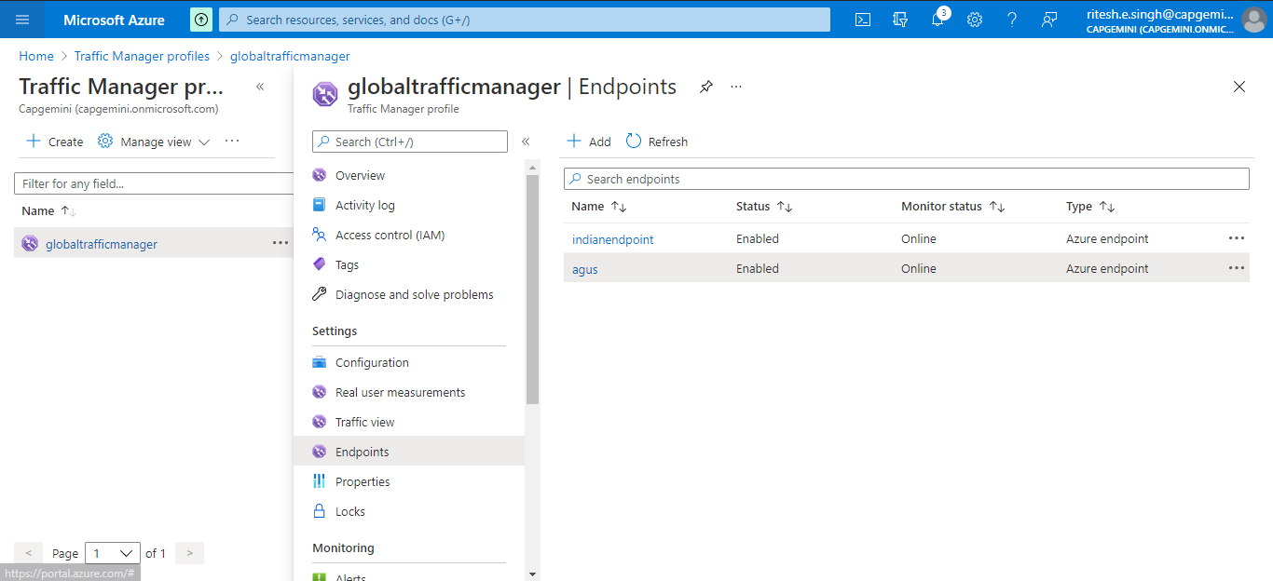

Domain – **rjc-dsai-project.ml**

Routing to Indian server

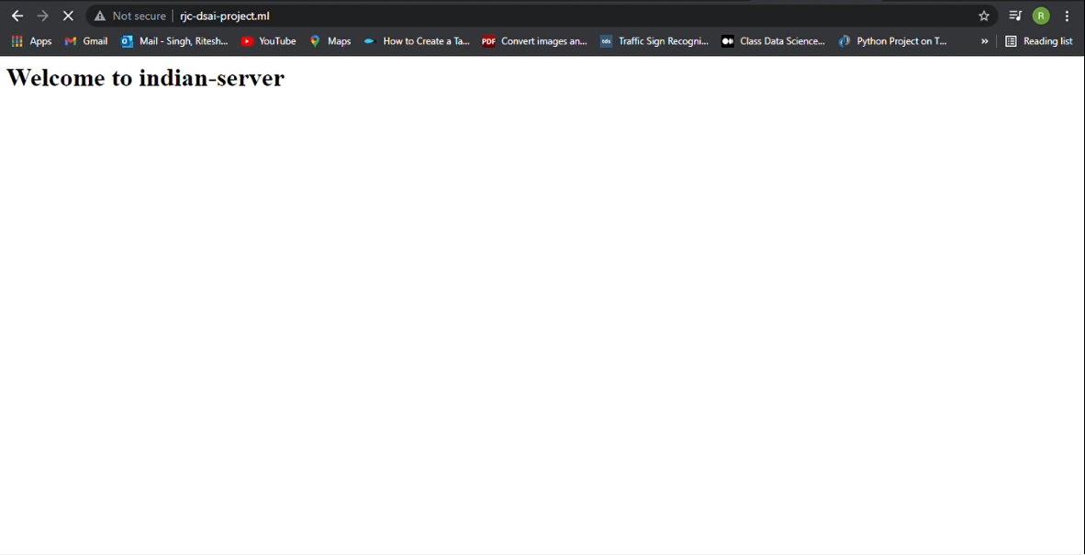

Connecting via VPN (US VPN)

Now the same domain is routing to US Server.

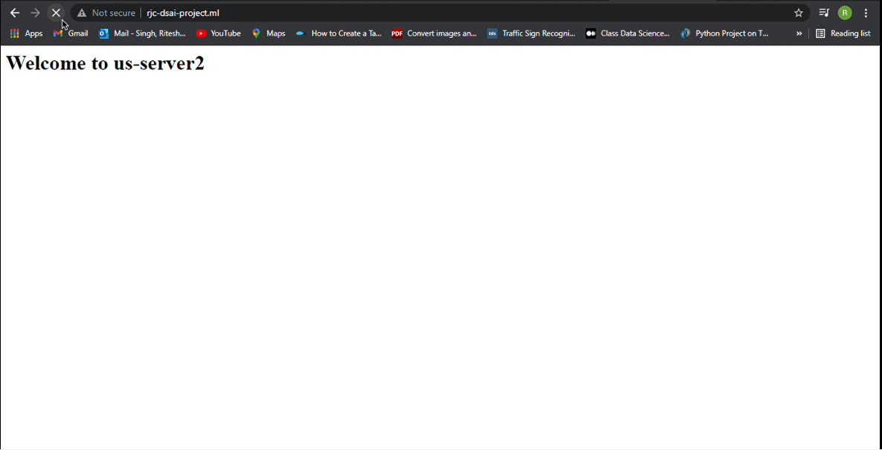

**Conclusion**

Deploying website in the clouds offer many advantages over the traditional way of running on premise data center. Firstly, using cloud computing allows rapid service deployment and massive savings upfront because not having to invest in infrastructure.Secondly, cloud computing model allows computing power and storage to scale up with business growth. In additionnn to this, its also easy to dynamically adjust computing power up or down. As a customer, you end up paying for the actual usage of resources.

**References**

**Intellipat**

<https://www.youtube.com/watch?v=KZL00HD5p88>

**Azure Portal**

<https://portal.azure.com>

**Microsoft Learn**

<https://docs.microsoft.com/en-us/learn/>

<https://docs.microsoft.com/en-us/learn/modules/intro-to-azure-fundamentals/what-is-microsoft-azure>